CSS ISLAMIC STUDIES · T9QA
بِسۡمِ ٱللَّهِ ٱلرَّحۡمَٰنِ ٱلرَّحِيمِ
Topic IX — The Islamic Code of Life — Sources of Law and the Islamic Systems
The Question Answers · Every past-paper question of Topic 9, 2015–2026, answered as a model
Eight model answers — the importance of the Sunnah, Ijma and its kinds (twice, the second with parliament), Ijtihad and its contemporary importance and principles, the Islamic economic system as the solution, the principles of Islamic economics, and the concentration of wealth. Each begins with an answer map that states exactly what the question asks.
Edition of September 2026 · covers the papers of 2015–2026 · written for CSS 2027 and after
Contents
HOW TO BUILD THE CONTENTS
The Contents below is left empty on purpose. In Microsoft Word, right-click anywhere on the grey line below and choose Update Field → Update entire table → OK. The full table of contents with page numbers will appear.
On a Mac: right-click (or Control-click) the line → Update Field. If you edit the notes later, repeat this step to refresh the page numbers. You can also press Ctrl + A then F9 (Windows) to update every field in the document at once.

How to Use These Answers 5
What is in this document 5
How every answer is built 5
Answer 1 · The Importance of the Sunnah in Interpretation and Legislation (CSS 2015) 6
Decoding the question 6
The model answer 6
(1) Introduction 6
(2) The authority of the Sunnah 7
(3) The importance of the Sunnah in interpretation 7
(4) The importance of the Sunnah in legislation 8
(5) The Sunnah as the living model 9
(6) The preservation of the Sunnah 9
(7) The Sunnah in Pakistan's law 10
(8) Why the Quran alone is not enough 10
(9) Conclusion 10
Why this answer scores 10
Answer 2 · Ijma: Definition, Kinds and Importance in the Light of the Quran and Sunnah (CSS 2017) 11
Decoding the question 11
The model answer 12
(1) Introduction 12
(2) Definition of Ijma 12
(3) The different kinds of Ijma 12
(4) The importance of Ijma in the light of the Quran 13
(5) The importance of Ijma in the light of the Sunnah 14
(6) The importance of Ijma in practice 14
(7) Conclusion 15
Why this answer scores 15
Answer 3 · Ijtihad and Its Contemporary Importance in the Light of Islamic Fiqh (CSS 2018) 16
Decoding the question 16
The model answer 16
(1) Introduction 16
(2) Definition of Ijtihad 17
(3) The contemporary importance of Ijtihad in the light of Islamic Fiqh 18
(4) Conclusion 19
Why this answer scores 20
Answer 4 · 'The Islamic Financial and Economic System Is the Solution of Human Financial Problems' (CSS 2020) 21
Decoding the question 21
The model answer 21
(1) Introduction 21
(2) The financial problems of humanity today 22
(3) Why the existing systems have failed 22
(4) The Islamic solution, problem by problem 22
(5) Evidence that it works 25
(6) Objections and the conditions for success 25
(7) Conclusion 26
Why this answer scores 26
Answer 5 · The Principles of Islamic Economics and Their Solutions to Contemporary Challenges (CSS 2022) 27
Decoding the question 27
The model answer 27
(1) Introduction 27
(2) The main principles of Islamic economics 28
(3) How these principles solve contemporary challenges 31
(4) Applying the principles — instruments and institutions 31
(5) Pakistan 31
(6) Conclusion 32
Why this answer scores 32
Answer 6 · The Concept, Importance and Principles of Ijtihad (CSS 2022) 33
Decoding the question 33
The model answer 33
(1) The concept of Ijtihad 33
(2) The importance of Ijtihad 35
(3) The principles of Ijtihad 35
(4) Principles in action — two examples 37
(5) Conclusion 38
Why this answer scores 38
Answer 7 · Ijma and Its Kinds; Can a Parliament's Legislation Be a Valid Consensus? (CSS 2023) 39
Decoding the question 39
The model answer 39
(1) Definition of Ijma 39
(2) The different kinds of Ijma 40
(3) Can legislation by a parliament be a valid consensus? 40
(4) Pakistan's experience 41
(5) What would make parliament's role stronger 42
(6) Conclusion 42
Why this answer scores 42
Answer 8 · The Disadvantages of Concentration of Wealth and Islam's Measures to Prevent It (CSS 2025) 43
Decoding the question 43
The model answer 44
(1) Introduction 44
(2) The disadvantages of concentration of wealth 44
(3) The economic measures Islam introduced to prevent concentration 45
(4) The lesson for Pakistan 47
(5) Conclusion 48
Why this answer scores 48

How to Use These Answers

What is in this document
# | Paper | Question (short) | Answer
1 | 2015 Q6 | The importance of the Sunnah in interpretation and legislation | Answer 1
2 | 2017 Q8 | Ijma: definition, kinds, importance in the Quran and Sunnah | Answer 2
3 | 2018 Q2 | Ijtihad: definition and contemporary importance | Answer 3
4 | 2020 Q8 | 'The Islamic financial and economic system is the solution of human financial problems' | Answer 4
5 | 2022 Q3 | Principles of Islamic economics and their solutions to contemporary challenges | Answer 5
6 | 2022 Q4 | Ijtihad: concept, importance and principles | Answer 6
7 | 2023 Q5 | Ijma and its kinds; can a parliament's legislation be a valid consensus? | Answer 7
8 | 2025 Q5 | Disadvantages of concentration of wealth; Islam's preventive measures | Answer 8

Repeated families get different shapes:
- Ijma (2017, 2023): 2017 builds on the evidence; 2023 spends half its space on parliament.
- Ijtihad (2018, 2022): 2018 builds on contemporary importance; 2022 on principles.
- Economics (2020, 2022): 2020 argues a thesis ('the solution'); 2022 lists principles, then matches them to challenges.

How every answer is built
1. The question, exactly as set.
2. The answer map — the centre states exactly what the question asks; every box is a heading, and every point is a complete idea.
3. Decoding the question.
4. The model answer — headings from the question's words; evidence Quran → Hadith → Companions and jurists → law and data; figures; Pakistan; a conclusion with a verse or hadith.
5. Why this answer scores.
TRAP · DEFINITION, EVIDENCE, EXAMPLE
In every Usul answer, give the literal and technical definition, the Quranic and Prophetic evidence, and one example for every kind. The examiner marks precision.

Answer 1 · The Importance of the Sunnah in Interpretation and Legislation (CSS 2015)
THE QUESTION · CSS 2015 · Q6 · 16 marks
Write a comprehensive note on the importance of Sunnah in interpretation and legislation.

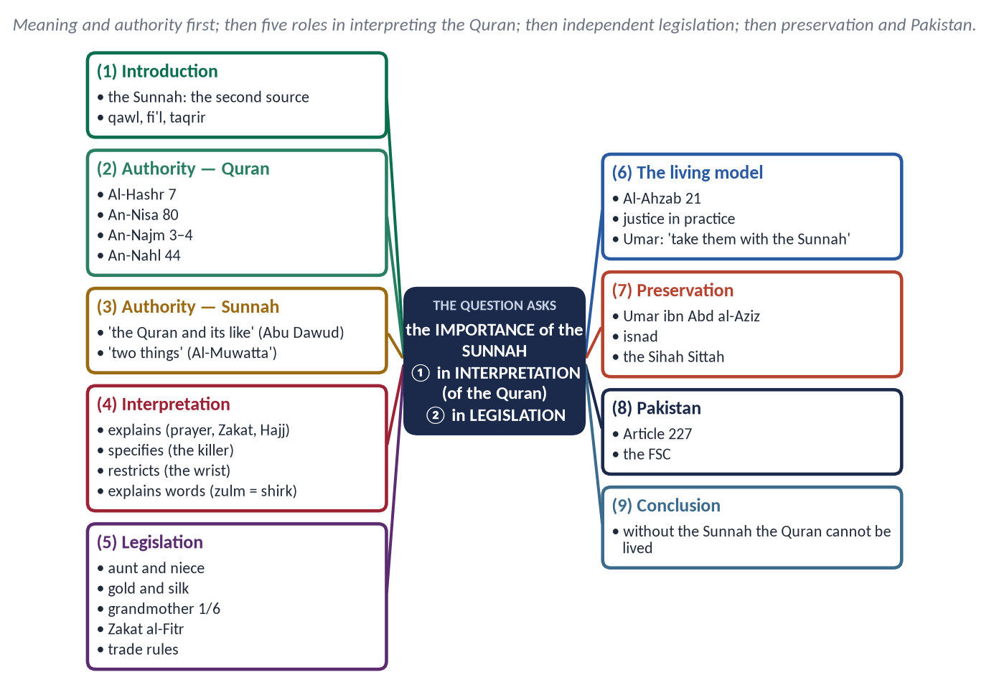
Figure 1 · The answer map: every branch is one numbered heading of the model answer below.

Decoding the question
- 'Comprehensive note' — full coverage: meaning, authority, the two roles, preservation.
- 'In interpretation' — how the Sunnah explains the Quran.
- 'In legislation' — how it makes law, including rulings not in the Quran.

The model answer

(1) Introduction
The Sunnah (سُنَّة) is everything reported from the Prophet ﷺ:
- his sayings (qawl);
- his actions (fi'l);
- his tacit approvals (taqrir).
It is the second source of Islamic law after the Quran. The Quran gives the principles; the Sunnah shows how to understand and live them.

(2) The authority of the Sunnah
✦ QURAN
﴿… كَيۡ لَا يَكُونَ دُولَةَۢ بَيۡنَ ٱلۡأَغۡنِيَآءِ مِنكُمۡۚ …﴾
“… so that it does not circulate only among the rich among you.” (Al-Hashr, Quran)
➜ 'Whatever the Messenger gives you, take it; and whatever he forbids you, refrain from it.'

✦ QURAN
﴿مَّن يُطِعِ ٱلرَّسُولَ فَقَدۡ أَطَاعَ ٱللَّهَۖ وَمَن تَوَلَّىٰ فَمَآ أَرۡسَلۡنَٰكَ عَلَيۡهِمۡ حَفِيظٗا﴾
“He who obeys the Messenger has obeyed Allah; but those who turn away - We have not sent you over them as a guardian.” (An-Nisa, Quran)
➜ 'Whoever obeys the Messenger has obeyed Allah.'

✦ QURAN
﴿وَمَا يَنطِقُ عَنِ ٱلۡهَوَىٰٓ ۝ إِنۡ هُوَ إِلَّا وَحۡيٞ يُوحَىٰ﴾
“Nor does he speak from [his own] inclination. It is not but a revelation revealed.” (An-Najm, Quran)
➜ Nor does he speak from his own desire. It is nothing but revelation revealed.

✦ HADITH
أَلَا إِنِّي أُوتِيتُ الْقُرْآنَ وَمِثْلَهُ مَعَهُ
“Indeed, I have been given the Quran and something like it along with it.” (Abu Dawud)

(3) The importance of the Sunnah in interpretation
✦ QURAN
﴿بِٱلۡبَيِّنَٰتِ وَٱلزُّبُرِۗ وَأَنزَلۡنَآ إِلَيۡكَ ٱلذِّكۡرَ لِتُبَيِّنَ لِلنَّاسِ مَا نُزِّلَ إِلَيۡهِمۡ وَلَعَلَّهُمۡ يَتَفَكَّرُونَ﴾
“[We sent them] with clear proofs and written ordinances. And We revealed to you the message that you may make clear to the people what was sent down to them and that they might give thought.” (An-Nahl, Quran)
➜ We sent down to you the Reminder so that you may make clear to people what was sent down to them.

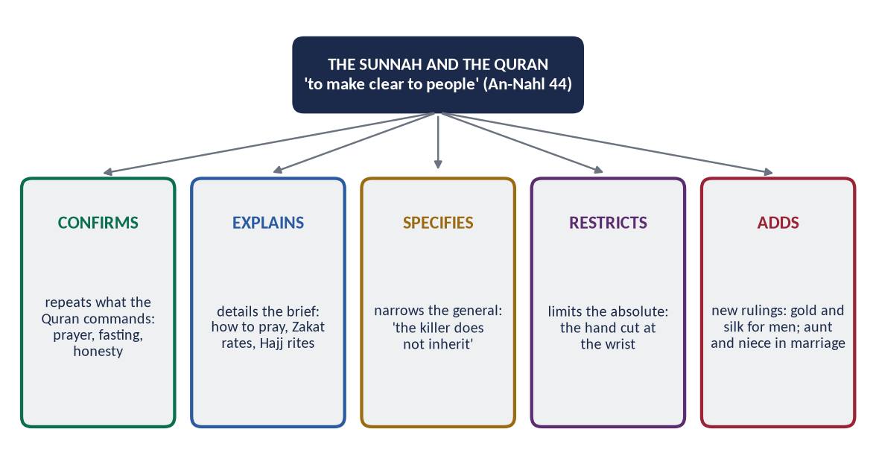
Figure 2 · The five roles of the Sunnah in relation to the Quran.

(i) It explains the brief (bayan al-mujmal)
- The Quran commands prayer. The Sunnah fixes its times, rak'ahs and method: 'Pray as you have seen me praying' (Al-Bukhari).
- The Quran commands Zakat. The Sunnah fixes the nisab and rates.
- The Quran commands Hajj. The Sunnah shows the rites: 'Take your rites from me' (Muslim).

(ii) It specifies the general (takhsis)
The Quran gives children inheritance in general terms (An-Nisa 11). The Sunnah excludes the killer: 'The killer does not inherit' (Al-Tirmidhi).

(iii) It restricts the absolute (taqyid)
'Cut off the hand of the thief' (Al-Ma'idah 38) is absolute. The Sunnah fixes the wrist and the minimum value.

(iv) It explains words and concepts
When Al-An'am 82 ('those who do not mix their faith with zulm') troubled the Companions, the Prophet ﷺ explained that zulm here means shirk, citing Luqman 13 (Al-Bukhari). 'The middle prayer' (Al-Baqarah 238) is 'Asr (Al-Bukhari and Muslim).

(v) It confirms
It repeats and strengthens the Quran's commands — honesty, kindness to parents, the sanctity of life.

(4) The importance of the Sunnah in legislation
The Sunnah also makes independent law (al-sunnah al-mustaqillah) where the Quran is silent. This is part of the authority Allah gave the Prophet ﷺ (Al-Hashr 7).
Ruling from the Sunnah | Source
No marriage to a woman and her paternal or maternal aunt together | Al-Bukhari and Muslim
Gold and silk forbidden for men | Al-Tirmidhi; Al-Nasa'i
The grandmother's share of one-sixth | Abu Dawud (confirmed by Abu Bakr after asking the Companions)
Domestic donkeys' meat and predatory animals forbidden | Al-Bukhari and Muslim
Zakat al-Fitr | Al-Bukhari and Muslim
No sale of gharar or of what one does not own | Muslim; Abu Dawud

Whole chapters of fiqh draw mostly on the Sunnah: the details of trade, judging, evidence, war and treaties.

Legislation in whole fields of law
- Judicial procedure and evidence come largely from the Sunnah: 'The burden of proof is on the claimant, and the oath on the one who denies' (Al-Tirmidhi); 'Do not judge for the first until you hear the other' (Al-Tirmidhi).
- International relations — the treatment of envoys and prisoners and the keeping of treaties — rest on the Prophet's ﷺ practice at Badr, Hudaybiyyah and the Conquest of Makkah.

(5) The Sunnah as the living model
✦ QURAN
﴿لَّقَدۡ كَانَ لَكُمۡ فِي رَسُولِ ٱللَّهِ أُسۡوَةٌ حَسَنَةٞ لِّمَن كَانَ يَرۡجُواْ ٱللَّهَ وَٱلۡيَوۡمَ ٱلۡأٓخِرَ وَذَكَرَ ٱللَّهَ كَثِيرٗا﴾
“There has certainly been for you in the Messenger of Allah an excellent pattern for anyone whose hope is in Allah and the Last Day and [who] remembers Allah often.” (Al-Ahzab, Quran)
➜ 'There has certainly been for you in the Messenger of Allah an excellent example.'

The Sunnah turns commands into practice:
- justice in his judgements;
- mercy in his treatment of enemies;
- fairness in his treaties;
- kindness in his home.
Umar (RA) said: 'People will come who argue with you using the ambiguous verses of the Quran. Take hold of them with the Sunnah, for the people of the Sunnah know the Book of Allah best' (Al-Darimi).

(6) The preservation of the Sunnah
- Writing in the Prophet's ﷺ time: 'Abdullah ibn 'Amr's Al-Sahifah al-Sadiqah.
- Official collection ordered by Umar ibn Abd al-Aziz (about 100 AH), through Ibn Shihab al-Zuhri.
- The sciences of isnad and rijal, which sort the sahih, hasan and da'if.
- The great collections: Al-Muwatta', and the Sihah Sittah led by Al-Bukhari and Muslim.

(7) The Sunnah in Pakistan's law
Article 227 of the Constitution requires every law to conform to 'the injunctions of Islam as laid down in the Holy Quran and Sunnah'. The Federal Shariat Court (Article 203) reviews laws against both.

(8) Why the Quran alone is not enough
Those who deny the Sunnah cannot pray, give Zakat or perform Hajj from the Quran alone. The Quran itself commands obedience to the Messenger. The Prophet ﷺ foresaw this claim and rejected it.
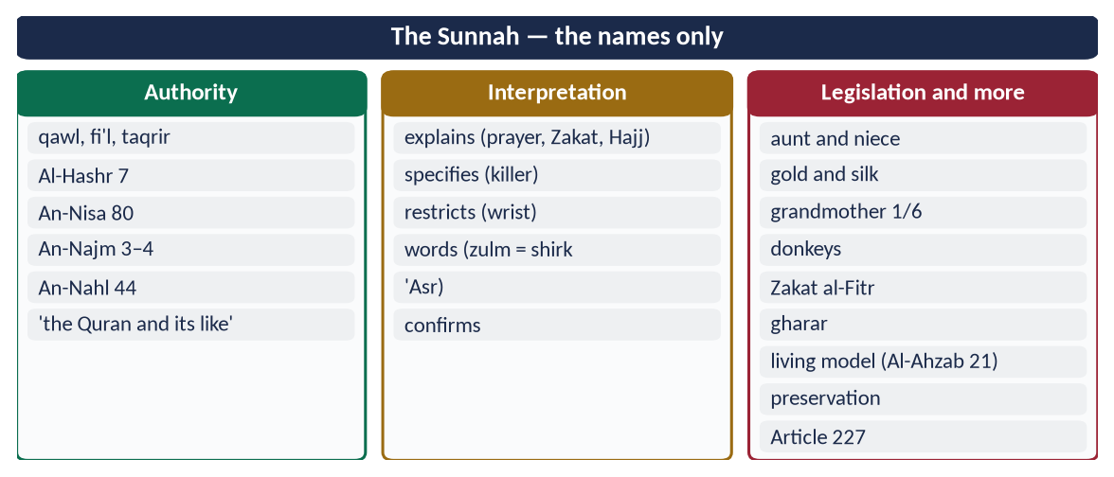
Figure 3 · At a glance — the Sunnah — the names only. The detail is in the sections above.

(9) Conclusion
✦ HADITH
تَرَكْتُ فِيكُمْ أَمْرَيْنِ لَنْ تَضِلُّوا مَا تَمَسَّكْتُمْ بِهِمَا: كِتَابَ اللَّهِ وَسُنَّةَ نَبِيِّهِ
“I have left among you two things; you will not go astray as long as you hold to them: the Book of Allah and the Sunnah of His Prophet.” (Al-Muwatta' (Malik))

The Sunnah is the key to the Quran and a source of law in its own right. In interpretation it explains, specifies, restricts and confirms. In legislation it adds rulings the Quran left to it. Without the Sunnah, the Quran could be recited but not lived.

Why this answer scores
- Both limbs — interpretation and legislation — get full headings, each with named examples.
- Authority is proved from the Quran and from the Sunnah before the roles are explained.
- Preservation and Article 227 make it 'comprehensive'.

Answer 2 · Ijma: Definition, Kinds and Importance in the Light of the Quran and Sunnah (CSS 2017)
THE QUESTION · CSS 2017 · Q8 · 20 marks
Define Ijma' (consensus) and explain its different kinds. Highlight its importance in the light of the Qur'ān and Sunnah.

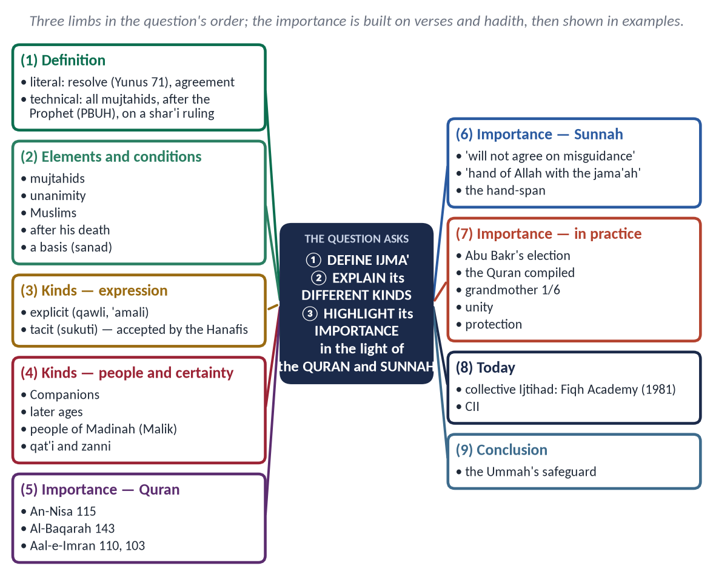
Figure 4 · The answer map: every branch is one numbered heading of the model answer below.

Decoding the question
- 'Define' — literal and technical definition, with its elements.
- 'Explain its different kinds' — each kind with a line of explanation and, where possible, an example.
- 'Highlight its importance in the light of the Quran and Sunnah' — importance proved by verses and hadith, not only described.

The model answer

(1) Introduction
After the Quran and Sunnah, Ijma' (consensus) is the third source of Islamic law. It is the Ummah's collective understanding, the safeguard that keeps the religion from individual error.

(2) Definition of Ijma

(i) Literal meaning
Ijma' (إِجْمَاع) has two meanings:
- firm resolve — 'so resolve upon your plan' (فَأَجْمِعُوا أَمْرَكُمْ, Yunus 71);
- agreement.

(ii) Technical meaning
Ijma' is the agreement of all the mujtahids of the Ummah of Muhammad ﷺ, in any age after his death, on a legal ruling.

(iii) Its elements and conditions
- Mujtahids — qualified jurists; the agreement of the general public is not technical Ijma.
- All of them — one qualified dissent prevents it (the majority view).
- Muslims of the Ummah of Muhammad ﷺ.
- After his death — in his life, his word was final.
- A shar'i ruling.
- A basis (sanad) in the Quran, Sunnah or Qiyas.

(3) The different kinds of Ijma

(i) By the way it is expressed
- Explicit Ijma (sarih) — every mujtahid states his opinion in words (qawli) or shows it in practice ('amali), and all agree. It is the strongest and certain.
- Tacit Ijma (sukuti) — some mujtahids give a view, it becomes widely known, and the others stay silent without objection after time to consider. The Hanafis accept it as a proof; al-Shafi'i, in his well-known view, did not treat it as certain.

(ii) By the people and the period
- Ijma of the Companions — the strongest in practice, accepted by all schools. Example: the Caliphate of Abu Bakr (RA).
- Ijma of the mujtahids of a later age — accepted by the majority.
- Ijma of the people of Madinah — Imam Malik treated their practice as authoritative, since they inherited the Prophet's ﷺ living Sunnah; other schools did not.

(iii) By its certainty
- Qat'i (certain) — explicit Ijma transmitted by mass transmission.
- Zanni (probable) — tacit Ijma, or Ijma reported by few narrators.

(4) The importance of Ijma in the light of the Quran
✦ QURAN
﴿وَمَن يُشَاقِقِ ٱلرَّسُولَ مِنۢ بَعۡدِ مَا تَبَيَّنَ لَهُ ٱلۡهُدَىٰ وَيَتَّبِعۡ غَيۡرَ سَبِيلِ ٱلۡمُؤۡمِنِينَ نُوَلِّهِۦ مَا تَوَلَّىٰ وَنُصۡلِهِۦ جَهَنَّمَۖ وَسَآءَتۡ مَصِيرًا﴾
“And whoever opposes the Messenger after guidance has become clear to him and follows other than the way of the believers - We will give him what he has taken and drive him into Hell, and evil it is as a destination.” (An-Nisa, Quran)
➜ Whoever opposes the Messenger after guidance has become clear to him, and follows other than the way of the believers, We will give him what he has taken and drive him into Hell.

✦ QURAN
﴿وَكَذَٰلِكَ جَعَلۡنَٰكُمۡ أُمَّةٗ وَسَطٗا لِّتَكُونُواْ شُهَدَآءَ عَلَى ٱلنَّاسِ وَيَكُونَ ٱلرَّسُولُ عَلَيۡكُمۡ شَهِيدٗاۗ …﴾
“And thus We have made you a middle (just) nation, that you may be witnesses over mankind and the Messenger a witness over you.” (Al-Baqarah, Quran)
➜ 'We have made you a middle (just) nation, that you may be witnesses over mankind.'

✦ QURAN
﴿كُنتُمۡ خَيۡرَ أُمَّةٍ أُخۡرِجَتۡ لِلنَّاسِ تَأۡمُرُونَ بِٱلۡمَعۡرُوفِ وَتَنۡهَوۡنَ عَنِ ٱلۡمُنكَرِ وَتُؤۡمِنُونَ بِٱللَّهِۗ …﴾
“You are the best nation brought forth for mankind: you enjoin what is right, forbid what is wrong, and believe in Allah.” (Aal-e-Imran, Quran)
➜ 'You are the best nation raised for mankind: you enjoin right and forbid wrong.'

✦ QURAN
﴿وَٱعۡتَصِمُواْ بِحَبۡلِ ٱللَّهِ جَمِيعٗا وَلَا تَفَرَّقُواْۚ وَٱذۡكُرُواْ نِعۡمَتَ ٱللَّهِ عَلَيۡكُمۡ إِذۡ كُنتُمۡ أَعۡدَآءٗ فَأَلَّفَ بَيۡنَ قُلُوبِكُمۡ فَأَصۡبَحۡتُم بِنِعۡمَتِهِۦٓ إِخۡوَٰنٗا …﴾
“And hold firmly to the rope of Allah all together and do not become divided. Remember Allah's favour upon you: you were enemies, and He brought your hearts together, and by His favour you became brothers.” (Aal-e-Imran, Quran)
➜ 'Hold fast to the rope of Allah all together and do not be divided.'

(5) The importance of Ijma in the light of the Sunnah
✦ HADITH
إِنَّ أُمَّتِي لَا تَجْتَمِعُ عَلَى ضَلَالَةٍ
“My Ummah will not agree upon misguidance.” (Ibn Majah)

✦ HADITH
إِنَّ اللَّهَ لَا يَجْمَعُ أُمَّتِي عَلَى ضَلَالَةٍ، وَيَدُ اللَّهِ مَعَ الْجَمَاعَةِ
“Allah will not gather my Ummah upon misguidance, and the hand of Allah is with the jama'ah.” (Al-Tirmidhi)

✦ HADITH
مَنْ فَارَقَ الْجَمَاعَةَ شِبْرًا فَمَاتَ، فَمِيتَةٌ جَاهِلِيَّةٌ
“Whoever separates from the community by a hand-span and dies, dies a death of Jahiliyyah.” (Al-Bukhari and Muslim)

These reports, through many chains, together give certainty that the Ummah as a whole is protected from agreeing on error.

(6) The importance of Ijma in practice

(i) It preserved the religion itself
The compilation of the Quran under Abu Bakr (12 AH) and Uthman's standard copy rest on the Companions' consensus.

(ii) It settled the state
The Companions agreed on the Caliphate of Abu Bakr and on fighting those who refused Zakat.

(iii) It fixed rulings
- The grandmother's share of one-sixth, after al-Mughirah and Muhammad ibn Maslamah reported the Prophet's ﷺ ruling.
- The prohibition of marrying a grandmother, extended from 'your mothers' (An-Nisa 23).

(iv) It secures unity and stability
Settled questions are not reopened every generation, so the Ummah shares a common core across all schools.

(v) It protects against individual error
No single scholar or ruler can impose a view against the consensus of the qualified.

(vi) It answers new questions
In modern form, as collective Ijtihad, through the International Islamic Fiqh Academy of the OIC (1981) and Pakistan's Council of Islamic Ideology.

(vii) It sets the limits of difference
Where there is Ijma, no one may break it; where there is none, the jurists may differ, and their reasoned differences are respected. This is why the four schools, differing in hundreds of details, remain one Ummah agreed on the fundamentals.
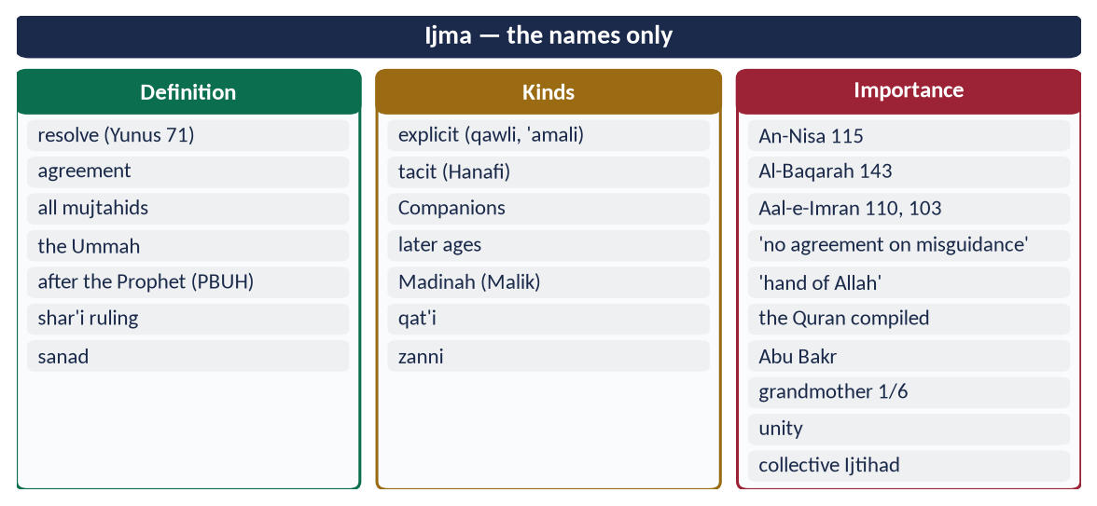
Figure 5 · At a glance — ijma — the names only. The detail is in the sections above.

(7) Conclusion
Ijma is the Ummah's collective conscience. It is grounded in the Quran's praise of 'the way of the believers' and the Prophet's ﷺ promise that his Ummah will not agree on misguidance. It preserved the Quran, settled the state and fixed the law. Today, through collective Ijtihad, it can guide the Ummah on questions the early jurists never faced.

Why this answer scores
- Three limbs answered in the question's order.
- Every kind is defined and exemplified; the school views (Hanafi, Maliki, Shafi'i) show depth.
- Importance is proved from four verses and three hadith, then shown in practice.

Answer 3 · Ijtihad and Its Contemporary Importance in the Light of Islamic Fiqh (CSS 2018)
THE QUESTION · CSS 2018 · Q2 · 20 marks
Define Ijtihad, also highlight its contemporary importance in the light of Islamic Fiqh.

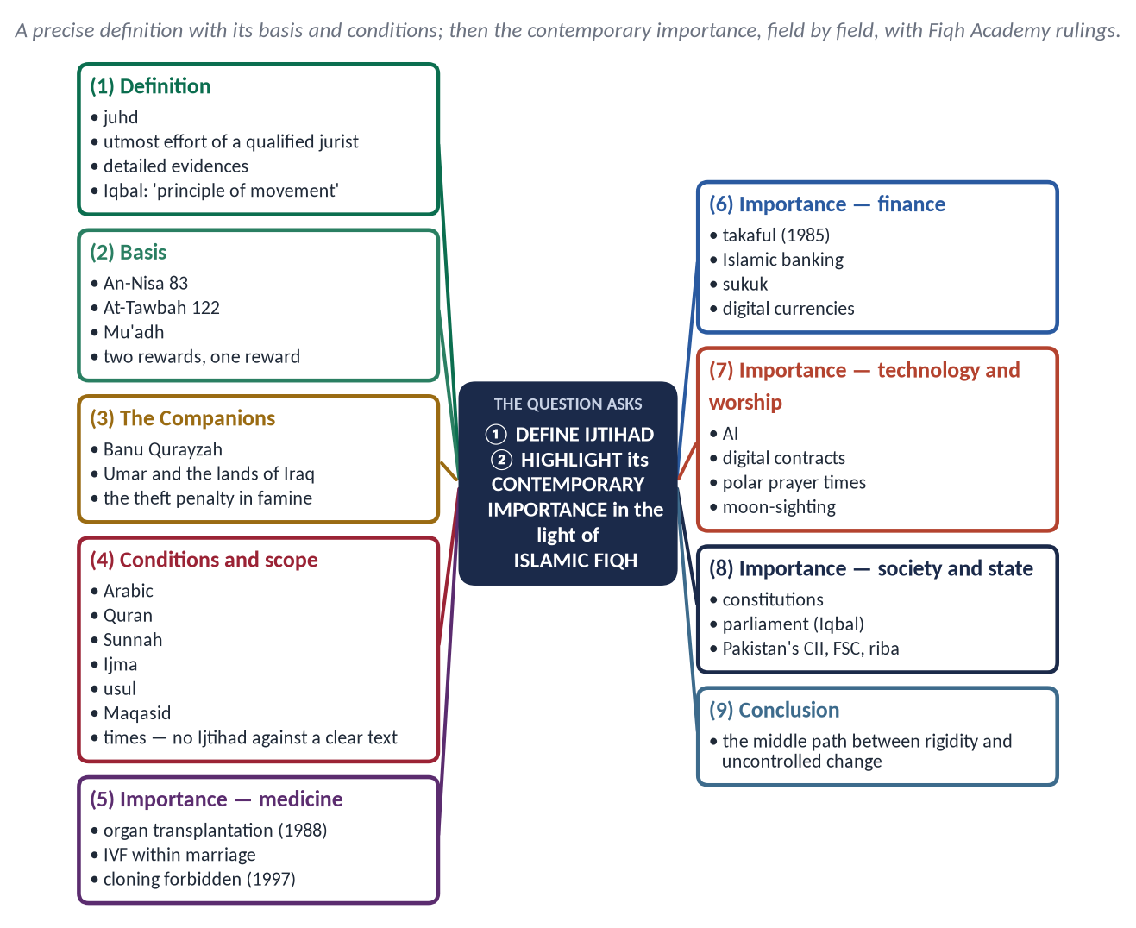
Figure 6 · The answer map: every branch is one numbered heading of the model answer below.

Decoding the question
- 'Define Ijtihad' — the literal and technical definition, with its basis and conditions. This is the shorter limb.
- 'Contemporary importance in the light of Islamic Fiqh' — why Ijtihad is needed today, shown through modern fiqh rulings. This is the main limb.

The model answer

(1) Introduction
Islam's texts are fixed, but life keeps changing. Ijtihad is the method by which the fixed principles of the Shari'ah meet new questions.
✦ SCHOLARLY VIEW
Allama Muhammad Iqbal · The Reconstruction of Religious Thought in Islam, Lecture VI
“The principle of movement in the structure of Islam.”
➜ Iqbal's definition of Ijtihad.

(2) Definition of Ijtihad

(i) Literal meaning
Ijtihad (اِجْتِهَاد) comes from juhd (جُهْد), effort. It means exerting oneself to the utmost in a difficult task.

(ii) Technical meaning
Ijtihad is the utmost effort of a qualified jurist (mujtahid) to derive a practical legal ruling from its detailed evidences — the Quran, the Sunnah, Ijma and Qiyas.

(iii) Its basis
✦ QURAN
﴿… وَلَوۡ رَدُّوهُ إِلَى ٱلرَّسُولِ وَإِلَىٰٓ أُوْلِي ٱلۡأَمۡرِ مِنۡهُمۡ لَعَلِمَهُ ٱلَّذِينَ يَسۡتَنۢبِطُونَهُۥ مِنۡهُمۡۗ …﴾
“If they had referred it to the Messenger and to those in authority among them, those who can draw conclusions from it would have known it.” (An-Nisa, Quran)
➜ If they had referred it to the Messenger and to those in authority among them, those who can draw conclusions from it would have known it.

✦ HADITH
إِذَا حَكَمَ الْحَاكِمُ فَاجْتَهَدَ ثُمَّ أَصَابَ فَلَهُ أَجْرَانِ، وَإِذَا حَكَمَ فَاجْتَهَدَ ثُمَّ أَخْطَأَ فَلَهُ أَجْرٌ
“When a judge rules, having striven, and is right, he has two rewards; if he strives and errs, he has one reward.” (Al-Bukhari and Muslim)

Mu'adh ibn Jabal (RA), sent to Yemen, said he would judge by the Quran, then the Sunnah, then 'I will use my own judgement and spare no effort' — and the Prophet ﷺ approved (Abu Dawud; Al-Tirmidhi).

(iv) The Companions practised it
- At Banu Qurayzah, the Prophet ﷺ approved two different readings of one command.
- Umar (RA) kept the lands of Iraq as state land for future generations, and suspended the penalty for theft in the famine of 18 AH.

(v) Its conditions and scope
- Conditions: mastery of Arabic, the Quran (especially its roughly 500 legal verses), the Sunnah, Ijma, usul al-fiqh and the Maqasid, and knowledge of the times; the mujtahid must be upright.
- Scope: 'No Ijtihad where there is a clear text.' Ijtihad works where the text is probable in meaning or where there is no text.

(3) The contemporary importance of Ijtihad in the light of Islamic Fiqh

(i) Medicine and bioethics
The classical books never discussed transplants or test-tube babies. Modern collective Ijtihad has:
- allowed organ transplantation with conditions — consent, no sale, no harm to the donor (International Islamic Fiqh Academy, 1988);
- allowed IVF within marriage, using the couple's own cells;
- forbidden human reproductive cloning (1997) and surrogacy that mixes lineage;
- examined brain death and life support.
The principles used are the protection of life and lineage (Maqasid), and 'necessity' with its limits.

(ii) Finance and economics
- Takaful (cooperative insurance) was approved in place of commercial insurance (Fiqh Academy, 1985).
- Islamic banking products — murabahah, ijarah, musharakah, diminishing musharakah for house finance.
- Sukuk in place of interest-bearing bonds.
- Stock markets — screening of permissible shares.
- Digital currencies — debated through the rules of gharar and the nature of money.
Without Ijtihad, Muslims would face a choice between riba and exclusion from modern economic life.

(iii) Technology
- Artificial intelligence — responsibility for harm, honesty of generated content.
- Online contracts — does clicking 'accept' create a valid offer and acceptance?
- Cybercrime and data privacy — judged through 'do not spy' (Al-Hujurat 12) and the protection of honour and wealth.

(iv) Worship in new conditions
- Prayer and fasting times in polar regions, where the sun does not set or rise for months — scholars allow following the nearest normal region or Makkah.
- Moon-sighting and the role of astronomical calculation.
- Prayer on aircraft and trains; the direction of the qiblah in space.

(v) Environment
Climate change, pollution and water shortage are addressed through man as trustee (khalifah) and the protection of life. 'Do not spread corruption on earth after it has been set right' (Al-A'raf 56).

(vi) State and society
- Constitutions, elections and parliaments as Shura.
- Citizenship of non-Muslims in a modern state.
- Iqbal's proposal: Ijtihad through an elected Muslim legislative assembly guided by scholars (Lecture VI).

(vii) Family and social questions
- The registration of marriages and divorces, to protect the rights of women and children.
- DNA and forensic evidence in criminal cases.
- Women's work in professions and public life, within the Shari'ah's limits.
All of these are answered through maslahah and the Maqasid of protecting lineage and justice.

(viii) Pakistan
The Council of Islamic Ideology (Articles 228–231) and the Federal Shariat Court (Article 203) are institutional Ijtihad. Their riba judgements (1991; 2022) and the growth of Islamic banking are its fruits.

(ix) Unity and balance
Collective Ijtihad brings scholars of all schools together. It also answers two extremes: rigidity that refuses all new questions, and unqualified 'reform' that changes the religion itself.
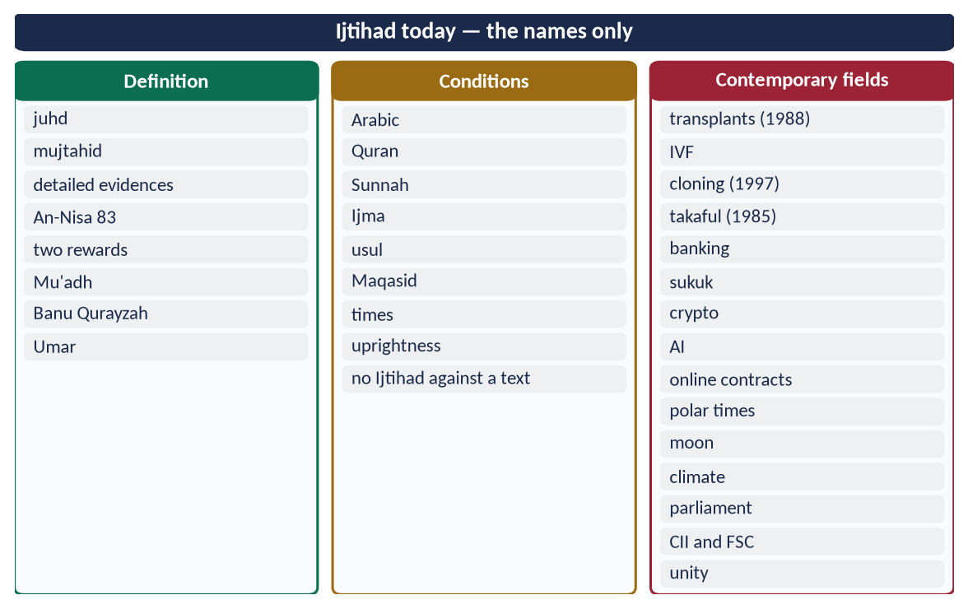
Figure 7 · At a glance — ijtihad today — the names only. The detail is in the sections above.

(4) Conclusion
✦ QURAN
﴿وَمَا كَانَ ٱلۡمُؤۡمِنُونَ لِيَنفِرُواْ كَآفَّةٗۚ فَلَوۡلَا نَفَرَ مِن كُلِّ فِرۡقَةٖ مِّنۡهُمۡ طَآئِفَةٞ لِّيَتَفَقَّهُواْ فِي ٱلدِّينِ وَلِيُنذِرُواْ قَوۡمَهُمۡ إِذَا رَجَعُوٓاْ إِلَيۡهِمۡ لَعَلَّهُمۡ يَحۡذَرُونَ﴾
“And it is not for the believers to go forth [to battle] all at once. For there should separate from every division of them a group [remaining] to obtain understanding in the religion and warn their people when they return to them that they might be cautious.” (At-Tawbah, Quran)
➜ Why should not a party from every group go forth to gain understanding in religion, and warn their people when they return?

Ijtihad is the Shari'ah's own tool for meeting the future. Disciplined by its conditions and guided by the Maqasid, it keeps the law faithful to the texts and alive to the times. For today's Ummah, and for Pakistan's constitutional promise of Islamic law, it is a duty, not an option.

Why this answer scores
- A precise definition with its basis, Companions' practice, conditions and scope — in the shorter first limb.
- Contemporary importance is shown field by field, with named Fiqh Academy rulings and years — 'in the light of Islamic Fiqh'.
- Pakistan's institutions and Iqbal add relevance.

Answer 4 · 'The Islamic Financial and Economic System Is the Solution of Human Financial Problems' (CSS 2020)
THE QUESTION · CSS 2020 · Q8 · 20 marks
"Islamic Financial and Economic system is the solution of the human financial problems". Discuss.

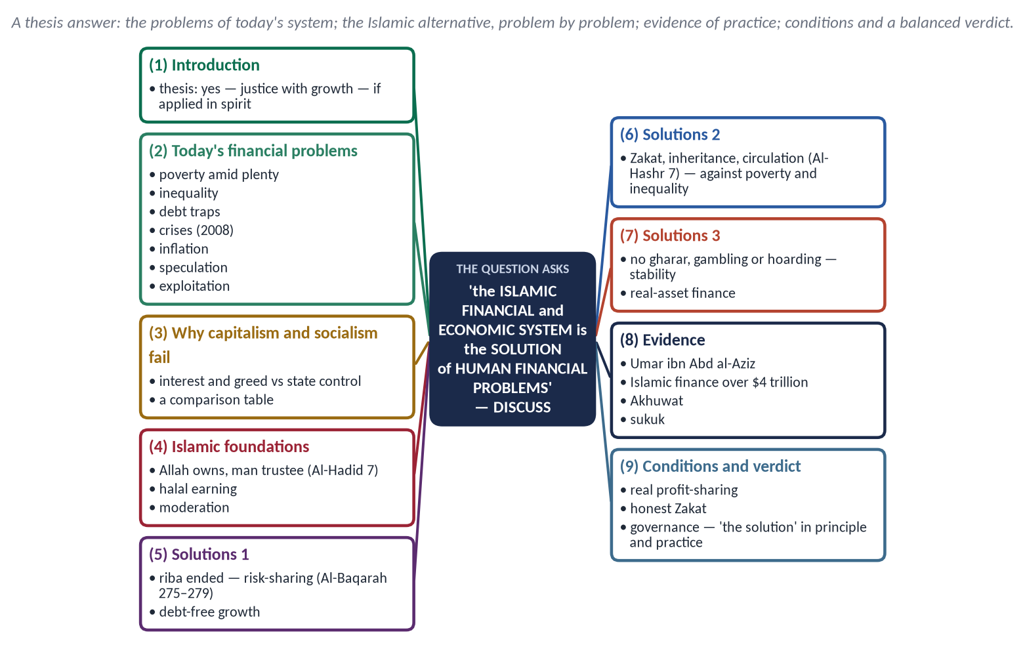
Figure 8 · The answer map: every branch is one numbered heading of the model answer below.

Decoding the question
- A quotation to 'discuss' — take a position, prove it, answer the objections, and give a balanced verdict.
- 'Financial and economic' — cover both finance (banking, debt, riba) and economics (poverty, distribution, growth).
- Show the problems first, then show that Islam solves them.

The model answer

(1) Introduction
The world has more wealth than ever, yet millions are poor and in debt, and every decade brings a financial crisis. The Islamic economic system claims to be the answer because it joins markets with morality and growth with justice. The thesis of this answer: yes, it is the solution — when it is applied in its spirit and not only in its labels.

(2) The financial problems of humanity today
- Poverty amid plenty — hundreds of millions in extreme poverty beside unprecedented wealth.
- Inequality — the richest tenth own about three-quarters of global wealth (World Inequality Report 2022).
- Debt traps — households, companies and whole nations crushed by interest. For many developing countries, including Pakistan, interest payments take a large share of the budget.
- Financial crises — the 2008 crash began with speculation on debt ('sub-prime' mortgages sold and resold).
- Inflation and speculation — money chasing paper assets rather than real production.
- Exploitation of workers and consumers; consumerism and waste.

(3) Why the existing systems have failed
Point | Capitalism | Socialism | Islam
Ownership | Private, almost unlimited | State | Allah's; man is trustee — private, public and state, each within limits
Finance | Interest-based debt | State credit | Risk-sharing; interest forbidden
Distribution | Market alone | State alone | Market + Zakat + inheritance + welfare
Motive | Profit | Plan | Profit with morality and the Hereafter
Result | Growth with inequality and crises | Equality with stagnation | Growth with justice

(4) The Islamic solution, problem by problem

(i) The foundation — trusteeship
✦ QURAN
﴿ءَامِنُواْ بِٱللَّهِ وَرَسُولِهِۦ وَأَنفِقُواْ مِمَّا جَعَلَكُم مُّسۡتَخۡلَفِينَ فِيهِۖ فَٱلَّذِينَ ءَامَنُواْ مِنكُمۡ وَأَنفَقُواْ لَهُمۡ أَجۡرٞ كَبِيرٞ﴾
“Believe in Allah and His Messenger and spend out of that in which He has made you successors. For those who have believed among you and spent, there will be a great reward.” (Al-Hadid, Quran)
➜ Believe in Allah and His Messenger and spend of that in which He has made you trustees.

Wealth is a trust. The owner may enjoy and grow it, but must pay its dues and may not use it to harm others.

(ii) Debt traps and crises → the prohibition of riba
✦ QURAN
﴿… وَأَحَلَّ ٱللَّهُ ٱلۡبَيۡعَ وَحَرَّمَ ٱلرِّبَوٰاْۚ …﴾
“Allah has permitted trade and has forbidden riba.” (Al-Baqarah, Quran)

✦ QURAN
﴿… وَذَرُواْ مَا بَقِيَ مِنَ ٱلرِّبَوٰٓاْ إِن كُنتُم مُّؤۡمِنِينَ ۝ فَإِن لَّمۡ تَفۡعَلُواْ فَأۡذَنُواْ بِحَرۡبٖ مِّنَ ٱللَّهِ وَرَسُولِهِۦۖ وَإِن تُبۡتُمۡ فَلَكُمۡ رُءُوسُ أَمۡوَٰلِكُمۡ لَا تَظۡلِمُونَ وَلَا تُظۡلَمُونَ﴾
“… and give up what remains of riba, if you are believers. If you do not, then be informed of a war from Allah and His Messenger. But if you repent, you may have your principal — do no wrong and suffer no wrong.” (Al-Baqarah, Quran)
➜ … give up what remains of riba, if you are believers. If you do not, then be informed of a war from Allah and His Messenger. But if you repent, you may have your principal — do no wrong and suffer no wrong.

Interest makes money grow without risk or work, and loads the whole risk on the borrower. Islam replaces it with mudarabah and musharakah, where profit and loss are shared, so finance is tied to real, productive activity. A system without interest cannot build the towers of debt-on-debt that collapsed in 2008. After that crisis even the Vatican's newspaper (2009) suggested that banks study the ethics of Islamic finance.

(iii) Poverty → Zakat and social security
✦ QURAN
﴿إِنَّمَا ٱلصَّدَقَٰتُ لِلۡفُقَرَآءِ وَٱلۡمَسَٰكِينِ وَٱلۡعَٰمِلِينَ عَلَيۡهَا وَٱلۡمُؤَلَّفَةِ قُلُوبُهُمۡ وَفِي ٱلرِّقَابِ وَٱلۡغَٰرِمِينَ وَفِي سَبِيلِ ٱللَّهِ وَٱبۡنِ ٱلسَّبِيلِۖ فَرِيضَةٗ مِّنَ ٱللَّهِۗ وَٱللَّهُ عَلِيمٌ حَكِيمٞ﴾
“Zakah expenditures are only for the poor and for the needy and for those employed to collect [zakah] and for bringing hearts together [for Islam] and for freeing captives [or slaves] and for those in debt and for the cause of Allah and for the [stranded] traveler - an obligation [imposed] by Allah. And Allah is Knowing and Wise.” (At-Tawbah, Quran)
➜ Zakat is only for the poor and the needy …

- 2.5% of savings every year;
- 5–10% of crops;
- Sadaqah, waqf and the state's duty to meet basic needs, as Umar's Diwan did even for new-born children.

(iv) Inequality → circulation of wealth
✦ QURAN
﴿… كَيۡ لَا يَكُونَ دُولَةَۢ بَيۡنَ ٱلۡأَغۡنِيَآءِ مِنكُمۡۚ …﴾
“… so that it does not circulate only among the rich among you.” (Al-Hashr, Quran)
➜ So that it does not circulate only among the rich among you.

- Inheritance divides every estate among many heirs.
- Bequests are limited to one-third.
- Hoarding is forbidden: 'None hoards except a sinner' (Muslim).
- Essential resources are shared: 'Muslims are partners in water, pasture and fire' (Abu Dawud).

(v) Speculation and instability → no gharar, no gambling
✦ QURAN
﴿يَـٰٓأَيُّهَا ٱلَّذِينَ ءَامَنُوٓاْ إِنَّمَا ٱلۡخَمۡرُ وَٱلۡمَيۡسِرُ وَٱلۡأَنصَابُ وَٱلۡأَزۡلَٰمُ رِجۡسٞ مِّنۡ عَمَلِ ٱلشَّيۡطَٰنِ فَٱجۡتَنِبُوهُ لَعَلَّكُمۡ تُفۡلِحُونَ﴾
“O you who have believed, indeed, intoxicants, gambling, [sacrificing on] stone alters [to other than Allah], and divining arrows are but defilement from the work of Satan, so avoid it that you may be successful.” (Al-Ma'idah, Quran)
➜ Intoxicants, gambling … are filth from the work of Shaytan, so avoid them.

The Prophet ﷺ forbade gharar — the sale of what is uncertain or not owned (Muslim). This removes speculative derivatives and short-selling of what one does not have.

(vi) Exploitation → fair trade and fair wages
- 'Woe to those who give less in measure' (Al-Mutaffifin 1–3).
- 'Give the worker his wage before his sweat dries' (Ibn Majah).
- 'The truthful, trustworthy merchant is with the prophets' (Al-Tirmidhi).

(vii) Consumerism and waste → moderation
✦ QURAN
﴿وَٱلَّذِينَ إِذَآ أَنفَقُواْ لَمۡ يُسۡرِفُواْ وَلَمۡ يَقۡتُرُواْ وَكَانَ بَيۡنَ ذَٰلِكَ قَوَامٗا﴾
“And [they are] those who, when they spend, do so not excessively or sparingly but are ever, between that, [justly] moderate.” (Al-Furqan, Quran)
➜ Those who, when they spend, are neither extravagant nor miserly.

(5) Evidence that it works
- History: under Umar ibn Abd al-Aziz, reports say Zakat collectors in some provinces found no one poor enough to take it.
- Today:
- global Islamic finance has grown to over 4 trillion dollars (industry estimates, 2023);
- Malaysia runs a strong Islamic financial sector and professional Zakat institutions;
- in Pakistan, Islamic banking is about a quarter of banking assets;
- the government issues sukuk (since 2008);
- Akhuwat (2001) has given interest-free loans to millions.

(6) Objections and the conditions for success
- Objection: 'Islamic banks only relabel interest.' Reply: where banks rely on cost-plus sales benchmarked to interest rates, the criticism has force. The answer is more real risk-sharing (musharakah, mudarabah), not the abandonment of the system.
- Objection: 'It cannot work in a global interest-based economy.' Reply: Pakistan's Constitution now requires the elimination of riba before 1 January 2028. A phased plan — sukuk for government debt, Islamic monetary tools, training — makes it possible.
- Conditions:
- honest, efficient Zakat administration;
- good governance and accountability;
- education in Islamic finance;
- taqwa — without honesty, no system works.
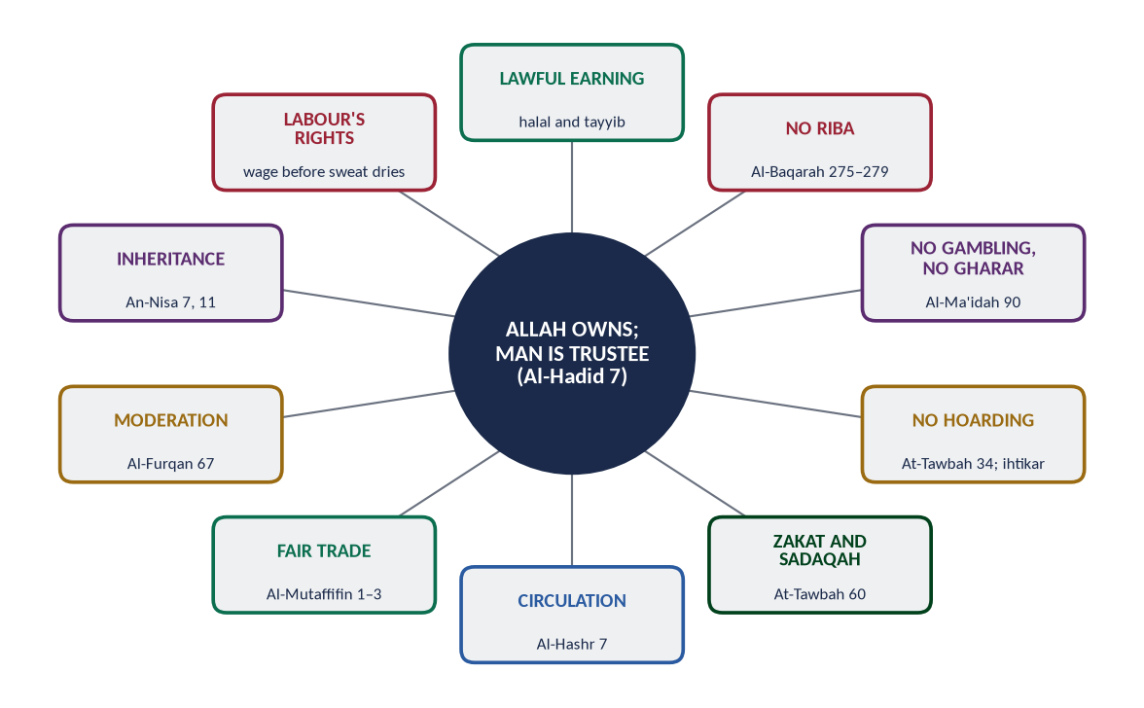
Figure 9 · The principles of the Islamic economic system.
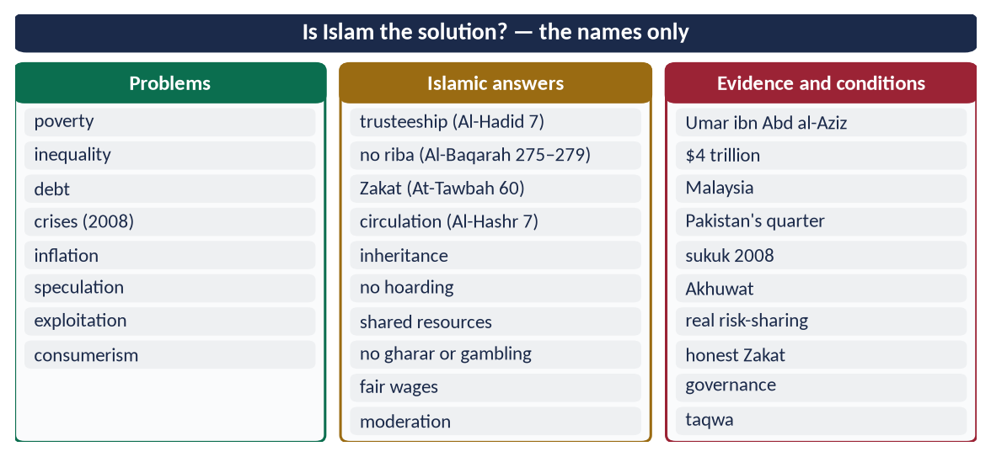
Figure 10 · At a glance — is Islam the solution? — the names only. The detail is in the sections above.

(7) Conclusion
✦ QURAN
﴿يَمۡحَقُ ٱللَّهُ ٱلرِّبَوٰاْ وَيُرۡبِي ٱلصَّدَقَٰتِۗ وَٱللَّهُ لَا يُحِبُّ كُلَّ كَفَّارٍ أَثِيمٍ﴾
“Allah destroys interest and gives increase for charities. And Allah does not like every sinning disbeliever.” (Al-Baqarah, Quran)
➜ 'Allah destroys riba and gives increase for charities.'

The Islamic financial and economic system is the solution to humanity's financial problems in principle. It ends debt slavery through risk-sharing, poverty through Zakat, inequality through circulation and inheritance, and instability through the ban on gharar and gambling. Whether it becomes the solution in practice depends on Muslims applying its spirit — justice and trust — and not only its forms.

Why this answer scores
- A clear thesis with a balanced verdict, as 'discuss' requires.
- Problems are matched one-to-one with Islamic solutions and verses.
- Evidence (history, data) and objections answered show depth.

Answer 5 · The Principles of Islamic Economics and Their Solutions to Contemporary Challenges (CSS 2022)
THE QUESTION · CSS 2022 · Q3 · 20 marks
Write down the main principles of Islamic Economics. How do these principles provide solutions to contemporary challenges?

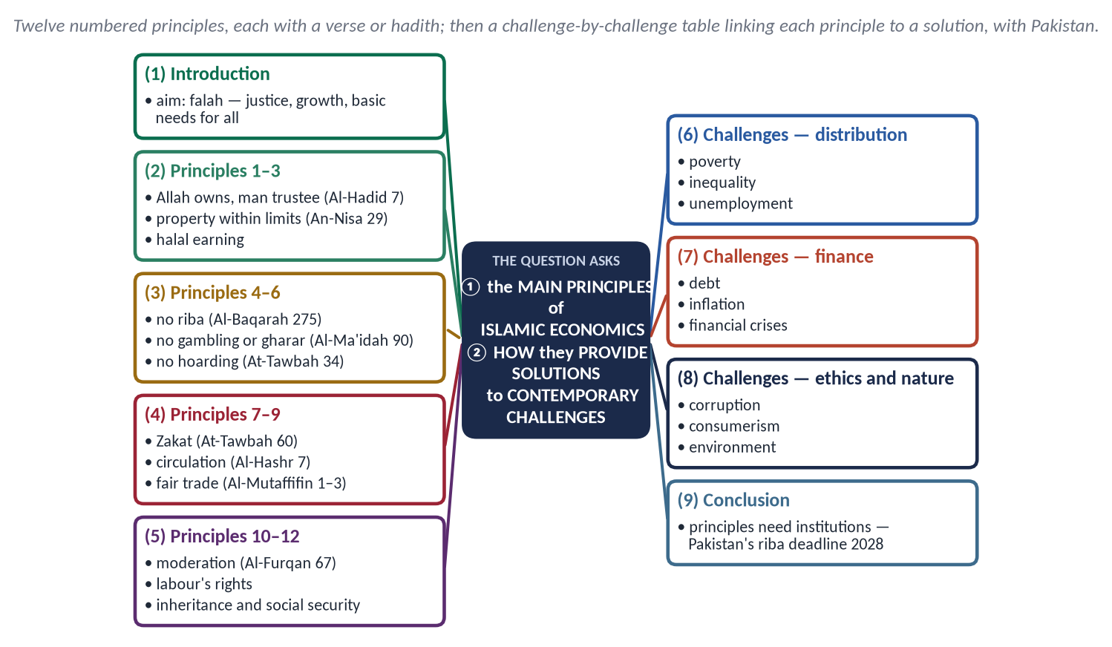
Figure 11 · The answer map: every branch is one numbered heading of the model answer below.

Decoding the question
- 'Write down the main principles' — a numbered list, each principle stated clearly with its evidence.
- 'How do these principles provide solutions to contemporary challenges?' — link each challenge to the principle that solves it. A table is ideal.

The model answer

(1) Introduction
Islamic economics is the organisation of economic life within the Shari'ah to achieve falah — success in this world and the next — through justice, growth and the meeting of everyone's basic needs. Its principles come from the Quran and Sunnah and were practised in the Islamic state from Madinah onwards.

(2) The main principles of Islamic economics
Figure 12 · The principles of the Islamic economic system.

(1) Allah is the owner; man is a trustee
✦ QURAN
﴿ءَامِنُواْ بِٱللَّهِ وَرَسُولِهِۦ وَأَنفِقُواْ مِمَّا جَعَلَكُم مُّسۡتَخۡلَفِينَ فِيهِۖ فَٱلَّذِينَ ءَامَنُواْ مِنكُمۡ وَأَنفَقُواْ لَهُمۡ أَجۡرٞ كَبِيرٞ﴾
“Believe in Allah and His Messenger and spend out of that in which He has made you successors. For those who have believed among you and spent, there will be a great reward.” (Al-Hadid, Quran)
➜ Spend of that in which He has made you trustees (mustakhlafin).

(2) Private property is protected, within limits
✦ QURAN
﴿… لَا تَأۡكُلُوٓاْ أَمۡوَٰلَكُم بَيۡنَكُم بِٱلۡبَٰطِلِ إِلَّآ أَن تَكُونَ تِجَٰرَةً عَن تَرَاضٖ مِّنكُمۡۚ …﴾
“Do not consume one another's wealth unjustly, but only in lawful trade by mutual consent.” (An-Nisa, Quran)
➜ Do not consume one another's wealth unjustly, but only by trade with mutual consent.

(3) Earning must be lawful and good
✦ QURAN
﴿يَـٰٓأَيُّهَا ٱلنَّاسُ كُلُواْ مِمَّا فِي ٱلۡأَرۡضِ حَلَٰلٗا طَيِّبٗا وَلَا تَتَّبِعُواْ خُطُوَٰتِ ٱلشَّيۡطَٰنِۚ إِنَّهُۥ لَكُمۡ عَدُوّٞ مُّبِينٌ﴾
“O mankind, eat from whatever is on earth [that is] lawful and good and do not follow the footsteps of Satan. Indeed, he is to you a clear enemy.” (Al-Baqarah, Quran)
➜ 'Eat of what is lawful and good on the earth.'

'No one has ever eaten better food than what he eats from the work of his own hands' (Al-Bukhari).

(4) Riba is forbidden
✦ QURAN
﴿… وَأَحَلَّ ٱللَّهُ ٱلۡبَيۡعَ وَحَرَّمَ ٱلرِّبَوٰاْۚ …﴾
“Allah has permitted trade and has forbidden riba.” (Al-Baqarah, Quran)

'The Messenger of Allah ﷺ cursed the one who consumes riba, the one who pays it, the one who writes it and its witnesses' (Muslim).

(5) Gambling and excessive uncertainty are forbidden
Al-Ma'idah 90 forbids maysir. The Prophet ﷺ forbade the sale of gharar (Muslim).

(6) Hoarding is forbidden
✦ QURAN
﴿… وَٱلَّذِينَ يَكۡنِزُونَ ٱلذَّهَبَ وَٱلۡفِضَّةَ وَلَا يُنفِقُونَهَا فِي سَبِيلِ ٱللَّهِ فَبَشِّرۡهُم بِعَذَابٍ أَلِيمٖ﴾
“And those who hoard gold and silver and do not spend it in the way of Allah — give them tidings of a painful punishment.” (At-Tawbah, Quran)
➜ Those who hoard gold and silver and do not spend it in the way of Allah — give them news of a painful punishment.

'None hoards (goods to raise prices) except a sinner' (Muslim).

(7) Zakat is compulsory
✦ QURAN
﴿إِنَّمَا ٱلصَّدَقَٰتُ لِلۡفُقَرَآءِ وَٱلۡمَسَٰكِينِ وَٱلۡعَٰمِلِينَ عَلَيۡهَا وَٱلۡمُؤَلَّفَةِ قُلُوبُهُمۡ وَفِي ٱلرِّقَابِ وَٱلۡغَٰرِمِينَ وَفِي سَبِيلِ ٱللَّهِ وَٱبۡنِ ٱلسَّبِيلِۖ فَرِيضَةٗ مِّنَ ٱللَّهِۗ وَٱللَّهُ عَلِيمٌ حَكِيمٞ﴾
“Zakah expenditures are only for the poor and for the needy and for those employed to collect [zakah] and for bringing hearts together [for Islam] and for freeing captives [or slaves] and for those in debt and for the cause of Allah and for the [stranded] traveler - an obligation [imposed] by Allah. And Allah is Knowing and Wise.” (At-Tawbah, Quran)
➜ Zakat is only for the poor, the needy … debtors, in the way of Allah and the traveller.

(8) Wealth must circulate
✦ QURAN
﴿… كَيۡ لَا يَكُونَ دُولَةَۢ بَيۡنَ ٱلۡأَغۡنِيَآءِ مِنكُمۡۚ …﴾
“… so that it does not circulate only among the rich among you.” (Al-Hashr, Quran)
➜ So that it does not circulate only among the rich among you.

(9) Trade must be fair
✦ QURAN
﴿وَيۡلٞ لِّلۡمُطَفِّفِينَ ۝ ٱلَّذِينَ إِذَا ٱكۡتَالُواْ عَلَى ٱلنَّاسِ يَسۡتَوۡفُونَ ۝ وَإِذَا كَالُوهُمۡ أَو وَّزَنُوهُمۡ يُخۡسِرُونَ﴾
“Woe to those who give less [than due]. Who, when they take a measure from people, take in full. But if they give by measure or by weight to them, they cause loss.” (Al-Mutaffifin, Quran)
➜ Woe to those who give less, who take full measure from people but give less when they measure for them.

(10) Moderation in spending
✦ QURAN
﴿وَٱلَّذِينَ إِذَآ أَنفَقُواْ لَمۡ يُسۡرِفُواْ وَلَمۡ يَقۡتُرُواْ وَكَانَ بَيۡنَ ذَٰلِكَ قَوَامٗا﴾
“And [they are] those who, when they spend, do so not excessively or sparingly but are ever, between that, [justly] moderate.” (Al-Furqan, Quran)
➜ Those who, when they spend, are neither extravagant nor miserly.

(11) The rights of labour
'Give the worker his wage before his sweat dries' (Ibn Majah); 'Your servants are your brothers … do not burden them beyond their capacity' (Al-Bukhari).

(12) Inheritance and social security
- An-Nisa 7 and 11 divide every estate among many heirs.
- The Bayt al-Mal guarantees basic needs, as Umar's Diwan did for all, Muslim and non-Muslim.

(3) How these principles solve contemporary challenges
Challenge | Principle | How it solves it
Poverty | Zakat (7); social security (12) | A yearly transfer from rich to poor; a guaranteed floor of basic needs
Inequality | Circulation (8); inheritance (12); no hoarding (6) | Wealth divided at every death; idle wealth taxed by Zakat; no monopolies
Debt crisis | No riba (4) | Risk-sharing (musharakah, mudarabah) and sukuk in place of interest-bearing loans
Financial crises | No gharar or gambling (5) | Finance tied to real assets; no speculative derivatives or debt-on-debt
Inflation | No hoarding (6); fair trade (9) | Goods kept in the market; honest prices
Unemployment | Halal earning (3); no riba (4) | Partnership finance for small enterprise; the dignity of work
Exploitation of workers | Labour's rights (11) | Fair wages paid on time; humane conditions
Corruption and fraud | Fair trade (9); halal earning (3) | Cheating and bribery forbidden; 'whoever cheats is not of me' (Muslim)
Consumerism and waste | Moderation (10) | 'The wasteful are brothers of the devils' (Al-Isra 27)
Environmental damage | Trusteeship (1) | Man as khalifah, not owner; 'do not spread corruption on earth' (Al-A'raf 56)

(4) Applying the principles — instruments and institutions
- Islamic banks using mudarabah, musharakah, murabahah and ijarah.
- Sukuk for government financing (Pakistan since 2008).
- Takaful in place of commercial insurance.
- Qard hasan — Akhuwat's interest-free loans (Pakistan, 2001).
- Waqf — endowments for health and education.
- State Zakat — Pakistan's Zakat and Ushr Ordinance (1980), which needs reform for trust and targeting.

(5) Pakistan
Pakistan faces heavy debt and interest payments, inflation, a narrow tax base and youth unemployment. The Federal Shariat Court (2022) and the 26th Amendment (2024) require riba to end before 1 January 2028. A phased shift to sukuk, Islamic monetary tools and partnership finance, with honest Zakat, would apply these principles to Pakistan's own challenges.
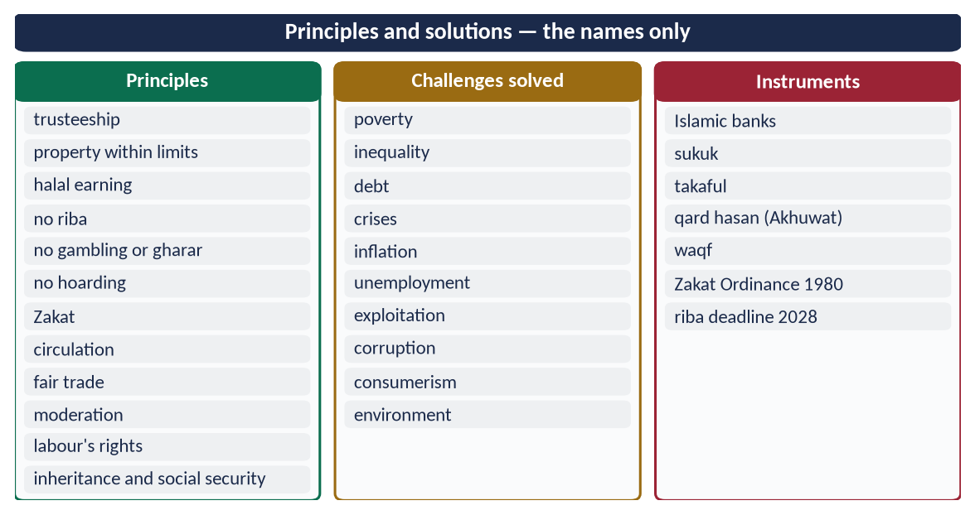
Figure 13 · At a glance — principles and solutions — the names only. The detail is in the sections above.

(6) Conclusion
✦ QURAN
﴿يَمۡحَقُ ٱللَّهُ ٱلرِّبَوٰاْ وَيُرۡبِي ٱلصَّدَقَٰتِۗ وَٱللَّهُ لَا يُحِبُّ كُلَّ كَفَّارٍ أَثِيمٍ﴾
“Allah destroys interest and gives increase for charities. And Allah does not like every sinning disbeliever.” (Al-Baqarah, Quran)
➜ 'Allah destroys riba and gives increase for charities.'

The principles of Islamic economics — trusteeship, lawful earning, the ban on riba, gambling, gharar and hoarding, Zakat, circulation, fair trade, moderation and the rights of labour — answer the central challenges of today: poverty, inequality, debt, instability and exploitation. They become solutions when they are built into institutions and practised with honesty.

Why this answer scores
- Twelve numbered principles, each with a verse or hadith, exactly as 'write down the main principles' asks.
- A three-column table links each challenge to its principle and solution.
- Instruments and Pakistan's 2028 deadline show application.

Answer 6 · The Concept, Importance and Principles of Ijtihad (CSS 2022)
THE QUESTION · CSS 2022 · Q4 · 20 marks
Elaborate the concept and importance of Ijtihad and explain its principles.

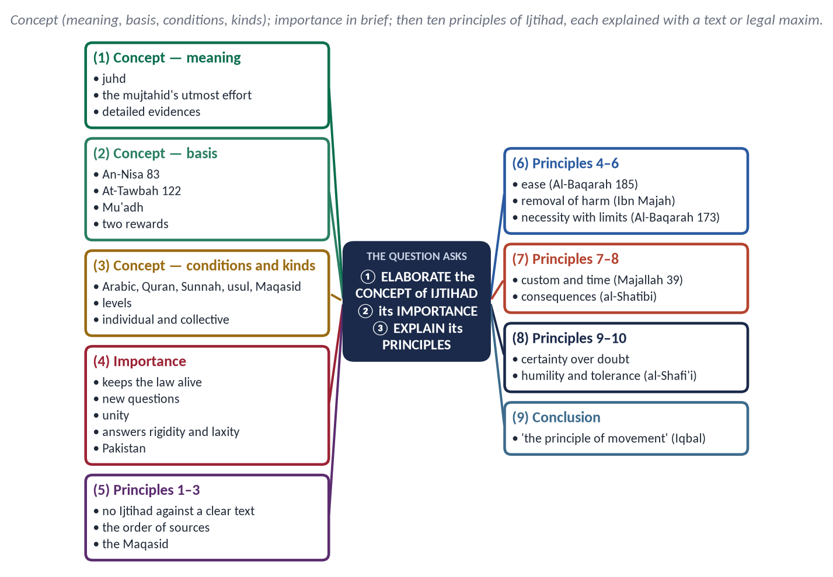
Figure 14 · The answer map: every branch is one numbered heading of the model answer below.

Decoding the question
- 'Elaborate the concept' — meaning, basis, conditions and kinds, in detail.
- 'Importance' — why it is needed, briefer here than in Answer 3.
- 'Explain its principles' — the rules that govern Ijtihad, each explained with evidence. This limb carries the most weight and the shape is new.

The model answer

(1) The concept of Ijtihad

(i) Meaning
Ijtihad (اِجْتِهَاد), from juhd (effort), is the utmost effort of a qualified jurist to derive a practical legal ruling from its detailed evidences. Iqbal called it 'the principle of movement in the structure of Islam' (Reconstruction, Lecture VI).

(ii) Basis
✦ QURAN
﴿… وَلَوۡ رَدُّوهُ إِلَى ٱلرَّسُولِ وَإِلَىٰٓ أُوْلِي ٱلۡأَمۡرِ مِنۡهُمۡ لَعَلِمَهُ ٱلَّذِينَ يَسۡتَنۢبِطُونَهُۥ مِنۡهُمۡۗ …﴾
“If they had referred it to the Messenger and to those in authority among them, those who can draw conclusions from it would have known it.” (An-Nisa, Quran)
➜ … those who can draw conclusions from it would have known it.

✦ QURAN
﴿وَمَا كَانَ ٱلۡمُؤۡمِنُونَ لِيَنفِرُواْ كَآفَّةٗۚ فَلَوۡلَا نَفَرَ مِن كُلِّ فِرۡقَةٖ مِّنۡهُمۡ طَآئِفَةٞ لِّيَتَفَقَّهُواْ فِي ٱلدِّينِ وَلِيُنذِرُواْ قَوۡمَهُمۡ إِذَا رَجَعُوٓاْ إِلَيۡهِمۡ لَعَلَّهُمۡ يَحۡذَرُونَ﴾
“And it is not for the believers to go forth [to battle] all at once. For there should separate from every division of them a group [remaining] to obtain understanding in the religion and warn their people when they return to them that they might be cautious.” (At-Tawbah, Quran)
➜ … a party from every group should go forth to gain understanding in religion.

✦ HADITH
إِذَا حَكَمَ الْحَاكِمُ فَاجْتَهَدَ ثُمَّ أَصَابَ فَلَهُ أَجْرَانِ، وَإِذَا حَكَمَ فَاجْتَهَدَ ثُمَّ أَخْطَأَ فَلَهُ أَجْرٌ
“When a judge strives and is right, he has two rewards; if he strives and errs, he has one reward.” (Al-Bukhari and Muslim)

The Prophet ﷺ approved Mu'adh's method — Book, Sunnah, then 'my own judgement' (Abu Dawud).

(iii) Conditions of the mujtahid
- Arabic;
- the Quran (legal verses, abrogation);
- the Sunnah (legal hadith and their authenticity);
- Ijma;
- usul al-fiqh and Qiyas;
- the Maqasid, which al-Shatibi made the first condition;
- knowledge of people and times;
- justice and piety.

(iv) Kinds
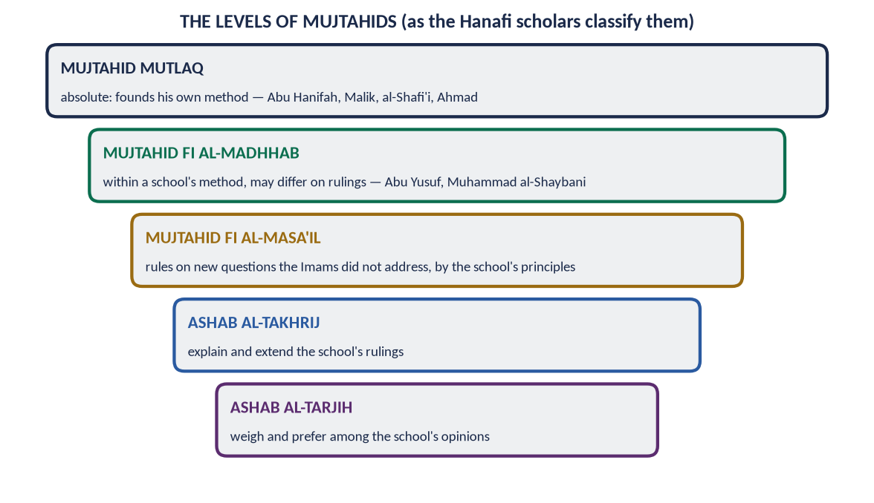
Figure 15 · The levels of mujtahids.
- By level: mujtahid mutlaq (the four Imams) down to the scholars who weigh opinions within a school.
- By number: individual and collective (the Fiqh Academy, the CII).
- By method: interpretation of texts (bayani), analogy (qiyasi), public interest (istislahi).

(2) The importance of Ijtihad
- It keeps the Shari'ah alive for every age and place.
- It answers new questions: transplants (Fiqh Academy, 1988), takaful (1985), sukuk, AI, polar prayer times.
- It shows the law's rationality — rulings have causes and purposes.
- It answers two extremes — rigid refusal of all change, and uncontrolled change.
- It unites the Ummah through collective councils of all schools.
- It serves Pakistan's constitutional promise — the CII and FSC, and the elimination of riba.

(3) The principles of Ijtihad

Principle 1 — No Ijtihad against a clear text
The maxim: لَا اجْتِهَادَ مَعَ النَّصِّ ('no Ijtihad where there is a text').
✦ QURAN
﴿وَمَا كَانَ لِمُؤۡمِنٖ وَلَا مُؤۡمِنَةٍ إِذَا قَضَى ٱللَّهُ وَرَسُولُهُۥٓ أَمۡرًا أَن يَكُونَ لَهُمُ ٱلۡخِيَرَةُ مِنۡ أَمۡرِهِمۡۗ وَمَن يَعۡصِ ٱللَّهَ وَرَسُولَهُۥ فَقَدۡ ضَلَّ ضَلَٰلٗا مُّبِينٗا﴾
“It is not for a believing man or a believing woman, when Allah and His Messenger have decided a matter, that they should [thereafter] have any choice about their affair. And whoever disobeys Allah and His Messenger has certainly strayed into clear error.” (Al-Ahzab, Quran)
➜ It is not for a believing man or woman, when Allah and His Messenger have decided a matter, to have any choice in it.

Ijtihad works in texts that are probable in meaning (zanni) or where there is no text — never against a certain ruling (the shares of inheritance, the prohibition of riba).

Principle 2 — Follow the order of sources
Quran → Sunnah → Ijma → Qiyas → secondary sources (istihsan, maslahah, 'urf). This is the order of Mu'adh's hadith and of An-Nisa 59.

Principle 3 — Serve the Maqasid al-Shari'ah
Every ruling must protect faith, life, intellect, lineage and wealth (al-Ghazali). A result that destroys any of them cannot be right. Example: organ donation was allowed because it saves life, with conditions that protect the donor.

Principle 4 — Ease and removal of hardship
✦ QURAN
﴿… يُرِيدُ ٱللَّهُ بِكُمُ ٱلۡيُسۡرَ وَلَا يُرِيدُ بِكُمُ ٱلۡعُسۡرَ …﴾
“Allah intends for you ease and does not intend for you hardship.” (Al-Baqarah, Quran)
➜ Allah intends ease for you, and does not intend hardship.

The maxim: المَشَقَّةُ تَجْلِبُ التَّيْسِيرَ ('hardship brings ease'). Example: combining prayers for travellers; the concessions for the sick.

Principle 5 — Harm must be removed
✦ HADITH
لَا ضَرَرَ وَلَا ضِرَارَ
“There is to be no harm and no returning of harm.” (Ibn Majah)

The maxim: الضَّرَرُ يُزَالُ ('harm is removed'). Example: laws against adulterated food and pollution.

Principle 6 — Necessity, but within limits
✦ QURAN
﴿… فَمَنِ ٱضۡطُرَّ غَيۡرَ بَاغٖ وَلَا عَادٖ فَلَآ إِثۡمَ عَلَيۡهِۚ …﴾
“But whoever is forced by necessity, neither desiring it nor transgressing, there is no sin upon him.” (Al-Baqarah, Quran)
➜ Necessity lifts the prohibition — but only without desire or excess.

The maxims: الضَّرُورَاتُ تُبِيحُ الْمَحْظُورَاتِ ('necessity makes the forbidden permissible') — but 'necessity is measured by its extent'. Example: a forbidden medicine only where no lawful one exists.

Principle 7 — Custom and changing times
'Custom is authoritative' (العَادَةُ مُحَكَّمَةٌ); 'the change of rulings with the change of times cannot be denied' (Majallah, Article 39). Example: Umar ended the share of 'those whose hearts are reconciled' once its cause had gone; maintenance (nafaqah) is set by local custom.

Principle 8 — Consider the consequences (ma'alat al-af'al)
Al-Shatibi taught that the jurist must look at where an act leads. The Prophet ﷺ did not rebuild the Ka'bah on Ibrahim's foundations, fearing the reaction of people new to Islam (Al-Bukhari). Blocking the means (sadd al-dhara'i') follows from this principle.

Principle 9 — Certainty is not removed by doubt
اليَقِينُ لَا يَزُولُ بِالشَّكِّ. A settled state (purity, innocence, ownership) stays until proved otherwise. Example: a person is innocent until proved guilty.

Principle 10 — Humility, and tolerance of difference
Ijtihad yields probable answers. Imam al-Shafi'i said: 'My view is correct with the possibility of error; another's view is wrong with the possibility of being correct.' Reasoned differences are respected. At Banu Qurayzah the Prophet ﷺ blamed neither group.

(4) Principles in action — two examples
Question | Principles applied
Takaful (1985) | No riba or gharar (1, 2); protect wealth (3); cooperation (Al-Ma'idah 2) → cooperative insurance allowed, commercial insurance not
Organ donation (1988) | Save life (3); remove harm (5); necessity with limits (6) → allowed with consent, no sale, no harm to the donor

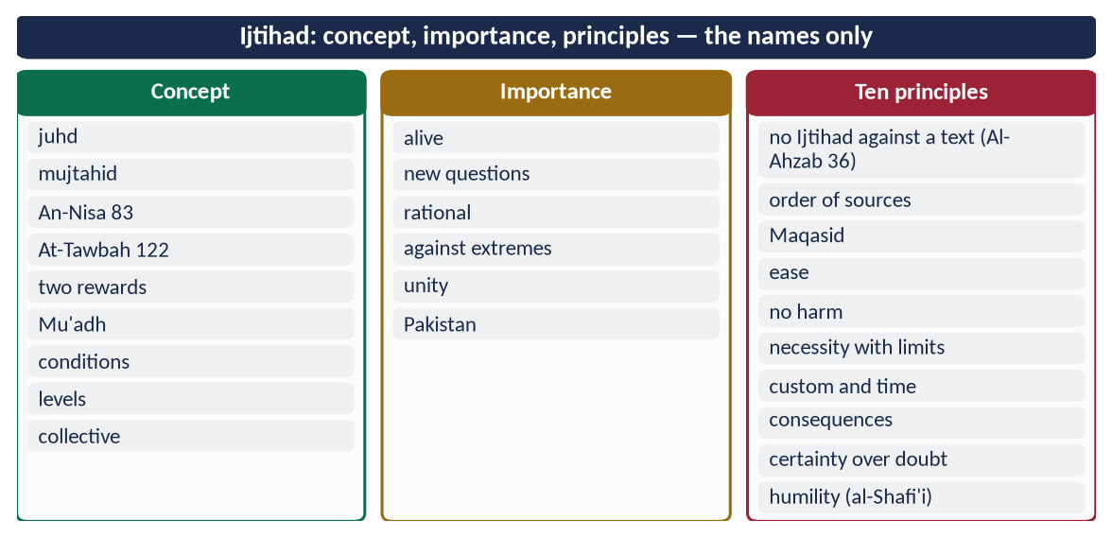
Figure 16 · At a glance — ijtihad: concept, importance, principles — the names only. The detail is in the sections above.

(5) Conclusion
Ijtihad is not freedom to change the religion; it is disciplined reasoning within the religion. Its ten principles — faithful to the text, ordered by the sources, guided by the Maqasid, easing hardship, removing harm, respecting custom, weighing consequences and practised with humility — make it, in Iqbal's words, 'the principle of movement' that keeps Islam's permanent law alive in changing times.

Why this answer scores
- Concept fully elaborated: meaning, basis, conditions, kinds.
- Ten principles, each with a verse, hadith or legal maxim in Arabic and an example — the heart of the question.
- Two worked examples show the principles in use.

Answer 7 · Ijma and Its Kinds; Can a Parliament's Legislation Be a Valid Consensus? (CSS 2023)
THE QUESTION · CSS 2023 · Q5 · 20 marks
Define Ijma (consensus) and explain its different kinds. Can legislation by a parliament of an Islamic state be regarded as a valid consensus?

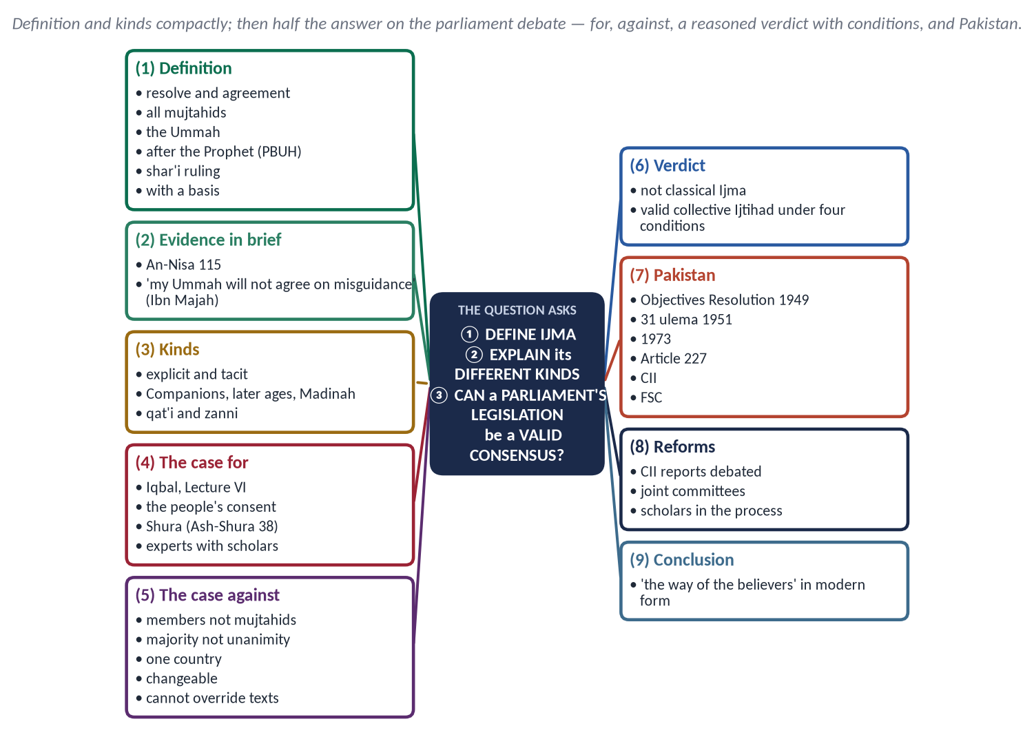
Figure 17 · The answer map: every branch is one numbered heading of the model answer below.

Decoding the question
- 'Define Ijma … explain its different kinds' — the same first limb as 2017, but answer it compactly.
- 'Can legislation by a parliament … be regarded as a valid consensus?' — a debate question. Give both sides, then a reasoned verdict. This limb decides the marks.

The model answer

(1) Definition of Ijma
Ijma' (إِجْمَاع) literally means firm resolve (Yunus 71) and agreement. Technically it is the agreement of all the mujtahids of the Ummah of Muhammad ﷺ, in any age after his death, on a legal ruling. Its conditions are:
- the agreeing people are qualified jurists;
- all of them agree;
- they are Muslims;
- it comes after the Prophet's ﷺ death;
- it rests on a basis (sanad) in the texts.
✦ QURAN
﴿وَمَن يُشَاقِقِ ٱلرَّسُولَ مِنۢ بَعۡدِ مَا تَبَيَّنَ لَهُ ٱلۡهُدَىٰ وَيَتَّبِعۡ غَيۡرَ سَبِيلِ ٱلۡمُؤۡمِنِينَ نُوَلِّهِۦ مَا تَوَلَّىٰ وَنُصۡلِهِۦ جَهَنَّمَۖ وَسَآءَتۡ مَصِيرًا﴾
“And whoever opposes the Messenger after guidance has become clear to him and follows other than the way of the believers - We will give him what he has taken and drive him into Hell, and evil it is as a destination.” (An-Nisa, Quran)
➜ Whoever opposes the Messenger … and follows other than the way of the believers, We will give him what he has taken.

✦ HADITH
إِنَّ أُمَّتِي لَا تَجْتَمِعُ عَلَى ضَلَالَةٍ
“My Ummah will not agree upon misguidance.” (Ibn Majah)

(2) The different kinds of Ijma
Kind | Explanation and example
Explicit (sarih) | Every mujtahid states his view or acts on it, and all agree. Certain. Example: the Caliphate of Abu Bakr (RA)
Tacit (sukuti) | Some state a view; the rest stay silent after knowing it. Accepted by the Hanafis; probable
Of the Companions | Accepted by all schools. Example: the compilation of the Quran
Of a later age | Mujtahids of any generation — accepted by the majority
Of the people of Madinah | Their practice was authoritative for Imam Malik; not for others
Qat'i / Zanni | Certain when explicit and mass-transmitted; probable when tacit or reported by few

(3) Can legislation by a parliament be a valid consensus?

(i) The case for — Iqbal and the modern need
✦ SCHOLARLY VIEW
Allama Muhammad Iqbal · The Reconstruction of Religious Thought in Islam, Lecture VI
“The transfer of the power of Ijtihad from individual representatives of schools to a Muslim legislative assembly which, in view of the growth of opposing sects, is the only possible form Ijma can take in modern times, will secure contributions to legal discussion from laymen who happen to possess a keen insight into affairs.”

- Consent of the Ummah. An elected assembly represents the whole people. Ijma is the 'way of the believers' (An-Nisa 115), and today that way is expressed through representation.
- Shura. 'Their affairs are by consultation among themselves' (Ash-Shura 38); a parliament is the modern institution of Shura.
- Experts with scholars. Modern laws on banking, medicine and technology need economists, doctors and engineers alongside jurists. An assembly can bring them together.
- Classical Ijma is no longer practical. Mujtahids are spread across dozens of states, and full agreement cannot be verified. Iqbal therefore saw the assembly as 'the only possible form'.
- Iqbal's safeguard. He suggested that scholars of Islamic law should form part of the assembly, or guide it, so that it would not err in interpretation.

(ii) The case against — why it is not classical Ijma
- Members are not mujtahids. Most legislators are not qualified jurists. Classical Ijma is the agreement of the qualified.
- Majority is not unanimity. A law passed by a simple majority, against a large minority, is not consensus.
- One nation is not the Ummah. Ijma is the agreement of the Ummah's jurists; one country's parliament speaks only for that country.
- Laws are changeable. A parliament can repeal its own laws, while classical Ijma is settled and binding on later generations.
- A vote cannot override revelation. No majority can make lawful what the Quran and Sunnah forbid (Al-Ahzab 36). A parliament without Islamic limits could legislate against the texts.

(iii) The reasoned verdict
Parliamentary legislation is not Ijma in the classical, binding sense. But it can be a valid form of collective Ijtihad — the modern, national expression of the principle behind Ijma — if four conditions are met:
- (a) Within the Quran and Sunnah — the assembly's power is limited by revelation. Pakistan's Article 227 says no law may be repugnant to the injunctions of Islam.
- (b) With qualified scholars — laws are prepared with the advice of jurists. Pakistan has the Council of Islamic Ideology (Articles 228–231).
- (c) Open to judicial review — a court can strike down laws repugnant to Islam. Pakistan has the Federal Shariat Court (Article 203).
- (d) By broad agreement — major laws should be passed by wide consensus across parties and schools, not a narrow majority.
Under these conditions the assembly's legislation earns the authority of collective Ijtihad. It binds the citizens of that state and deserves obedience (An-Nisa 59), while remaining open to correction — unlike the settled Ijma of the Companions.

(4) Pakistan's experience
- The Objectives Resolution (1949), passed by the Constituent Assembly, accepted the sovereignty of Allah and the limits He prescribes. It is now Article 2A.
- The 22 points of 31 ulema (1951) — scholars of all schools agreed on the basic principles of an Islamic state. It was a rare inter-school consensus, and it influenced constitution-making.
- The 1973 Constitution was adopted by broad agreement of the elected assembly, with its Islamic provisions (Articles 2, 2A, 31, 227–231).
- The riba judgements — the FSC (1991, 2022) and Parliament's 26th Amendment (2024), fixing the deadline of 1 January 2028 — show court and parliament working towards Islamic law together.

(5) What would make parliament's role stronger
- Debate the CII's reports within a fixed time. Many have never been discussed.
- Joint committees of legislators, scholars of all schools and experts on major laws.
- Research capacity for the CII and training of legislators in Islamic law.
- Wide consultation of scholars and public before major laws, in the spirit of Abd al-Rahman ibn Awf's three-day poll of the people.
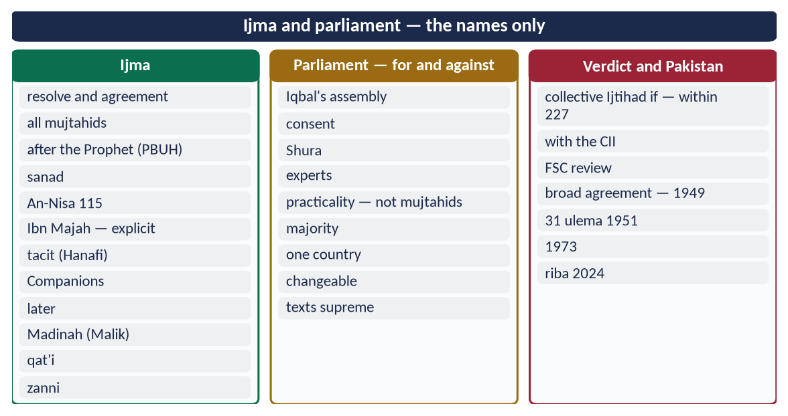
Figure 18 · At a glance — ijma and parliament — the names only. The detail is in the sections above.

(6) Conclusion
✦ QURAN
﴿وَٱلَّذِينَ ٱسۡتَجَابُواْ لِرَبِّهِمۡ وَأَقَامُواْ ٱلصَّلَوٰةَ وَأَمۡرُهُمۡ شُورَىٰ بَيۡنَهُمۡ وَمِمَّا رَزَقۡنَٰهُمۡ يُنفِقُونَ﴾
“And those who have responded to their lord and established prayer and whose affair is [determined by] consultation among themselves, and from what We have provided them, they spend.” (Ash-Shura, Quran)
➜ Their affairs are by consultation among themselves.

Ijma is the consensus of the Ummah's qualified jurists, in explicit and tacit forms, protected by the Prophet's ﷺ promise that his Ummah will not agree on misguidance. A modern parliament cannot claim that classical authority. But bound by the Quran and Sunnah, advised by scholars, reviewed by courts and acting by broad agreement, it can carry the spirit of Ijma forward — as Iqbal hoped — as the Ummah's collective Ijtihad in modern times.

Why this answer scores
- The first limb is compact but complete (a table of kinds), leaving room for the debate.
- The parliament question gets both sides, a conditional verdict and Pakistani examples.
- Iqbal is quoted exactly; the Constitution (2A, 227–231, 203) grounds the verdict.

Answer 8 · The Disadvantages of Concentration of Wealth and Islam's Measures to Prevent It (CSS 2025)
THE QUESTION · CSS 2025 · Q5 · 20 marks
What are the disadvantages of concentration of wealth? What economic measures has Islam introduced to prevent this concentration of wealth?

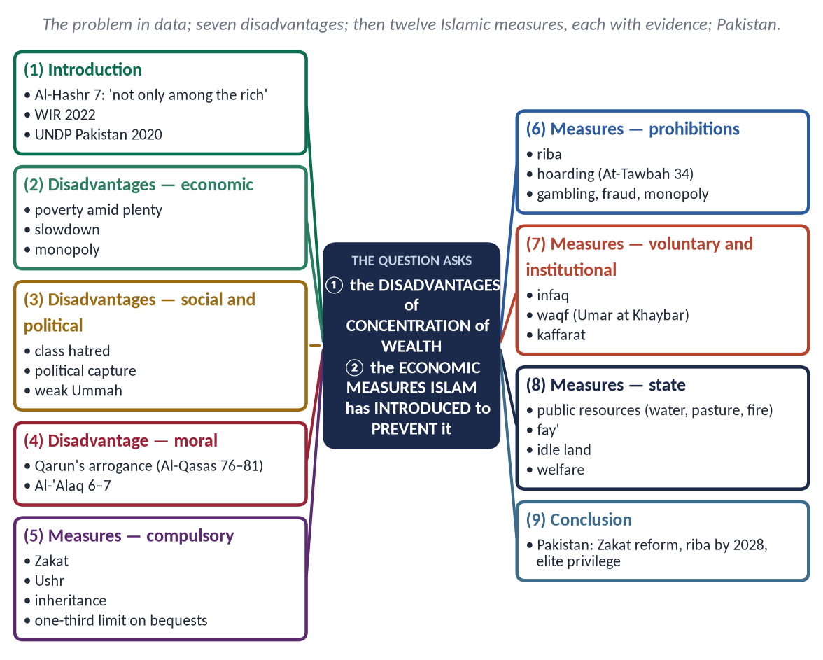
Figure 19 · The answer map: every branch is one numbered heading of the model answer below.

Decoding the question
- 'Disadvantages' — the harms of wealth in few hands: economic, social, political and moral.
- 'Economic measures Islam has introduced' — concrete institutions and laws, each with a verse or hadith, not general moral advice.

The model answer

(1) Introduction
✦ QURAN
﴿… كَيۡ لَا يَكُونَ دُولَةَۢ بَيۡنَ ٱلۡأَغۡنِيَآءِ مِنكُمۡۚ …﴾
“… so that it does not circulate only among the rich among you.” (Al-Hashr, Quran)
➜ So that it does not circulate only among the rich among you.

The Quran names concentration of wealth as a problem to be prevented. The problem is severe today:
- The World Inequality Report 2022 found that the richest 10% hold about three-quarters of global wealth, while the poorer half holds about 2%.
- In Pakistan, the UNDP's National Human Development Report (2020) estimated the privileges of elite groups at about 17.4 billion dollars a year, roughly 6% of GDP.

(2) The disadvantages of concentration of wealth

(i) Poverty amid plenty
When a few own most of the wealth, the many lack food, health care and education. Wealth that does not circulate does not reach those in need.

(ii) Economic slowdown
The poor spend what they get, while the rich save much of theirs. When wealth gathers at the top, demand falls, businesses close and jobs disappear. Hoarded wealth does not work for society.

(iii) Monopoly and exploitation
Concentrated wealth controls markets, prices and wages. Small traders are pushed out, and consumers and workers are exploited.

(iv) Class hatred and social unrest
Extreme inequality breeds envy, crime and conflict. Many revolutions in history followed such gaps.

(v) Political capture
Wealth buys influence over elections, laws and taxes. Policies begin to serve the few, and democracy turns into plutocracy.

(vi) Moral decay — the Qarun syndrome
✦ QURAN
﴿إِنَّ قَٰرُونَ كَانَ مِن قَوۡمِ مُوسَىٰ فَبَغَىٰ عَلَيۡهِمۡۖ …﴾
“Indeed, Qarun was from the people of Musa, but he tyrannised over them.” (Al-Qasas, Quran)

Qarun said, 'I was given it only because of knowledge I have' (Al-Qasas 78). His arrogance ended when the earth swallowed him and his house (Al-Qasas 81).
✦ QURAN
﴿كَلَّآ إِنَّ ٱلۡإِنسَٰنَ لَيَطۡغَىٰٓ ۝ أَن رَّءَاهُ ٱسۡتَغۡنَىٰٓ﴾
“No! [But] indeed, man transgresses. Because he sees himself self-sufficient.” (Al-Alaq, Quran)
➜ No! Indeed, man transgresses because he sees himself self-sufficient.

(vii) Weakness of the Ummah
A society split between the super-rich and the destitute cannot be united or strong.

(3) The economic measures Islam introduced to prevent concentration
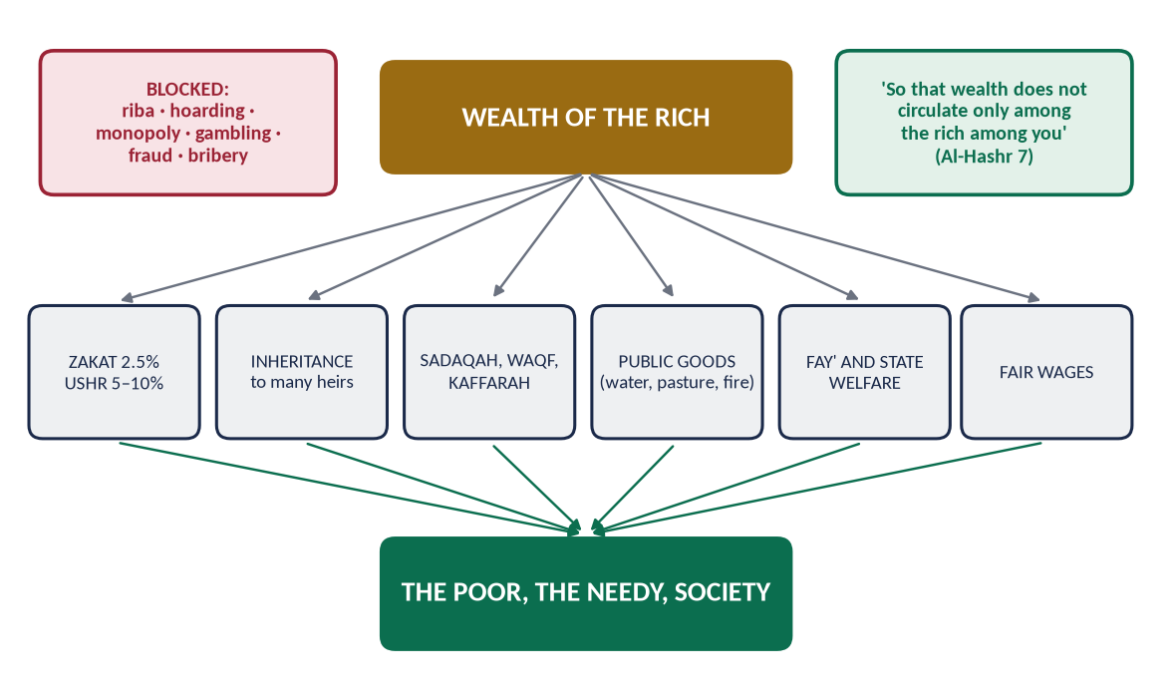
Figure 20 · How Islam moves wealth from the few to the many.

(i) Zakat — a yearly compulsory transfer
✦ HADITH
تُؤْخَذُ مِنْ أَغْنِيَائِهِمْ فَتُرَدُّ عَلَى فُقَرَائِهِمْ
“It is taken from their rich and returned to their poor.” (Al-Bukhari and Muslim)
➜ The Prophet's ﷺ instruction to Mu'adh.

- 2.5% of savings above the nisab every year;
- Ushr of 5–10% on crops;
- 20% on buried treasure.
Idle money shrinks each year, so owners are pushed to invest it.

(ii) The law of inheritance
At every death, wealth is divided among many heirs, men and women (An-Nisa 7, 11, 12, 176).
- Bequests are limited to one-third — 'a third, and a third is a lot' (Al-Bukhari and Muslim).
- A bequest cannot favour an heir.
- There is no primogeniture: great estates cannot pass whole to one son.

(iii) The prohibition of riba
✦ QURAN
﴿… وَأَحَلَّ ٱللَّهُ ٱلۡبَيۡعَ وَحَرَّمَ ٱلرِّبَوٰاْۚ …﴾
“Allah has permitted trade and has forbidden riba.” (Al-Baqarah, Quran)

Interest moves wealth from the borrower who works to the lender who waits — from the poor to the rich. Islam replaces it with profit-and-loss sharing.

(iv) The prohibition of hoarding
✦ QURAN
﴿… وَٱلَّذِينَ يَكۡنِزُونَ ٱلذَّهَبَ وَٱلۡفِضَّةَ وَلَا يُنفِقُونَهَا فِي سَبِيلِ ٱللَّهِ فَبَشِّرۡهُم بِعَذَابٍ أَلِيمٖ﴾
“And those who hoard gold and silver and do not spend it in the way of Allah — give them tidings of a painful punishment.” (At-Tawbah, Quran)
➜ Those who hoard gold and silver and do not spend it in the way of Allah — give them news of a painful punishment.

'None hoards (goods to raise prices) except a sinner' (Muslim).

(v) Voluntary spending (infaq)
✦ QURAN
﴿… وَيَسۡـَٔلُونَكَ مَاذَا يُنفِقُونَۖ قُلِ ٱلۡعَفۡوَۗ …﴾
“They ask you what they should spend. Say: 'The surplus.'” (Al-Baqarah, Quran)

✦ QURAN
﴿وَفِيٓ أَمۡوَٰلِهِمۡ حَقّٞ لِّلسَّآئِلِ وَٱلۡمَحۡرُومِ﴾
“And from their properties was [given] the right of the [needy] petitioner and the deprived.” (Adh-Dhariyat, Quran)
➜ In their wealth was a right for the one who asks and the deprived.

(vi) Waqf — permanent public wealth
When Umar (RA) received land at Khaybar, the Prophet ﷺ said: 'If you wish, keep the asset itself and give its produce in charity' (Al-Bukhari and Muslim). Waqfs later funded schools, hospitals, wells and inns across the Muslim world.

(vii) Public ownership of essential resources
✦ HADITH
الْمُسْلِمُونَ شُرَكَاءُ فِي ثَلَاثٍ: فِي الْكَلَإِ، وَالْمَاءِ، وَالنَّارِ
“Muslims are partners in three things: pasture, water and fire.” (Abu Dawud)
➜ Essential resources cannot be monopolised.

Umar kept the lands of Iraq as state property for all generations.

(viii) Distribution of state revenue (fay')
Al-Hashr 7 was revealed about the fay' of Banu Nadir, which the Prophet ﷺ gave to the poor Muhajirun, so that wealth would not stay with the rich.

(ix) Idle land returns to use
Umar (RA) took back uncultivated land from Bilal ibn al-Harith. The rule reported from him: whoever fences land and leaves it idle for three years loses his right (Abu Yusuf, Kitab al-Kharaj).

(x) Obligatory charities and expiations
Zakat al-Fitr, kaffarat (feeding the poor for broken oaths and missed fasts) and fidyah keep wealth flowing to the poor.

(xi) The ban on unjust gains
Gambling (Al-Ma'idah 90), gharar, fraud ('whoever cheats is not of me', Muslim), bribery (Al-Baqarah 188) and short measure (Al-Mutaffifin 1–3) are forbidden — the channels through which wealth is unjustly gathered.

(xii) Fair wages
'Give the worker his wage before his sweat dries' (Ibn Majah). Profit may not be made by robbing labour.

(4) The lesson for Pakistan
- Reform Zakat under the 1980 Ordinance into a trusted, digital, well-targeted system.
- End riba before 1 January 2028, as the 26th Amendment requires.
- Tax the rich fairly and remove elite privileges.
- Revive waqf and support interest-free finance such as Akhuwat.
- Enforce the law against hoarding and cartels.
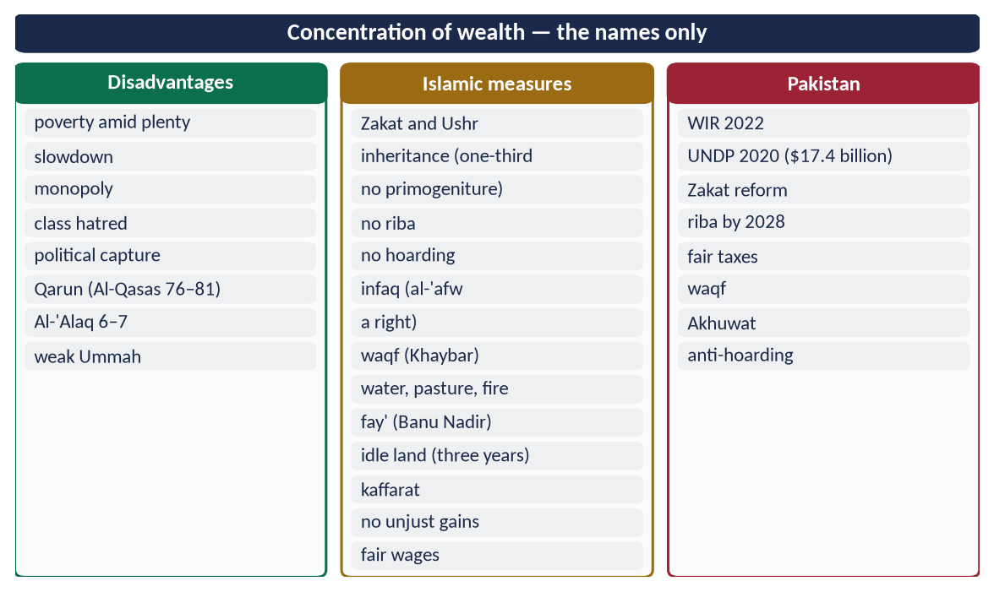
Figure 21 · At a glance — concentration of wealth — the names only. The detail is in the sections above.

(5) Conclusion
✦ QURAN
﴿ءَامِنُواْ بِٱللَّهِ وَرَسُولِهِۦ وَأَنفِقُواْ مِمَّا جَعَلَكُم مُّسۡتَخۡلَفِينَ فِيهِۖ فَٱلَّذِينَ ءَامَنُواْ مِنكُمۡ وَأَنفَقُواْ لَهُمۡ أَجۡرٞ كَبِيرٞ﴾
“Believe in Allah and His Messenger and spend out of that in which He has made you successors. For those who have believed among you and spent, there will be a great reward.” (Al-Hadid, Quran)
➜ Spend of that in which He has made you trustees.

Concentration of wealth produces poverty, slowdown, monopoly, unrest, political capture and arrogance. Islam answers with a complete set of economic institutions:
- Zakat and inheritance distribute wealth;
- the bans on riba and hoarding stop its unjust accumulation;
- waqf and public ownership share it;
- the state guarantees basic needs.
All serve one Quranic aim: wealth must not circulate only among the rich.

Why this answer scores
- Seven disadvantages grouped by type, with data and the Quranic story of Qarun.
- Twelve concrete measures, each with a verse or hadith — 'economic measures', not general advice.
- Pakistan applies the answer.

